Day 1 ---> Introduction,Installation , basic Job

Day 2----> Basic cong, Auth and auth,Job chaning, Git Integration, views , Tools

Day 3----> More plugins, Jobs in detail, Maven Integration

Day 4----> Jenkins pipeline

* Jenkins Beginner Session 1 - Introduction and Getting Started
* Topic: Installing Jenkins 2
* Jenkins installation – standalone installation , tomcat with Jnekins
* Jenkins Beginner Session 3 - How to change Home Directory
* Jenkins Beginner Session 4 - How to use CLI - command line interface--**
* Jenkins Beginner Session 5 - How to create Users + Manage + Assign Roles
* Jenkins Beginner Session 6 - Basic Configurations
* Jenkins Beginner Session 8 - Jenkins integration with GIT (SCM)
* Jenkins Beginner Session 9 - How to use CATLIGHT (Jenkins Build Monitor)
* Jenkins Beginner Session 10 - What is Automated Deployment (Step by Step) **
* Jenkins Beginner Session 11 - What is Pipeline in Jenkins (DevOps) **
* Jenkins Beginner Session 12 - How to setup DELIVERY PIPELINE in Jenkins (Step by Step)
* Jenkins Beginner Session 13 - How to setup BUILD PIPELINE in Jenkins (Step by Step)













•Version control-Git GitHub(SCM)

•Integration—Jenkins, Building code is not only involved compilation, but it also includes **unit testing, integration testing, code review**, and **packaging**.

•Continuous Delivery (continuous testing)—once the build is done jenkins will deploy the app on test server, for unit testing ,UAT, functional once done

•Continous Deployment (Configuration mgt and containerization)—tested build will be deployed on prod server,maven ,gradle,

Day 1:

<https://www.jenkins.io/download/>

Jenkins –Installation

Step 1 : Download Jenkins war file - https://jenkins.io/

https://updates.jenkins-ci.org/download/war/

Step 2 : Place the war file into any location on your system

Step 3 : goto command prompt (windows) | terminal (mac)

- goto folder where jenkins.war is

- java -jar jenkins.war

- java -jar jenkins.war --httpPort=9090

Step 4 : goto browser - http://localhost:8080 (Jenkins window should show up)

Step 5 : install required plugins

Step 6 : get started with Jenkins

Note: By default Jenkins runs at port 8080. To run jenkins on a different port.

Use the following command at command prompt:

manisha manisha@123--nov

--Method 1: Run Jenkins in a standalone mode

https://updates.jenkins-ci.org/download/war

user name : admin

Demo 1:

Create a job Test1:

Echo “hello”

Demo 2: run a java code

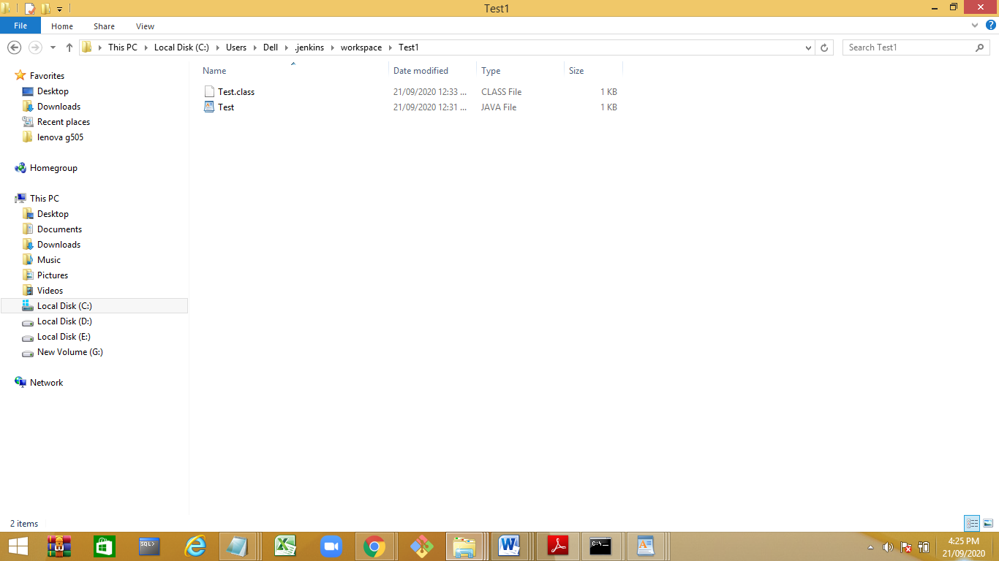

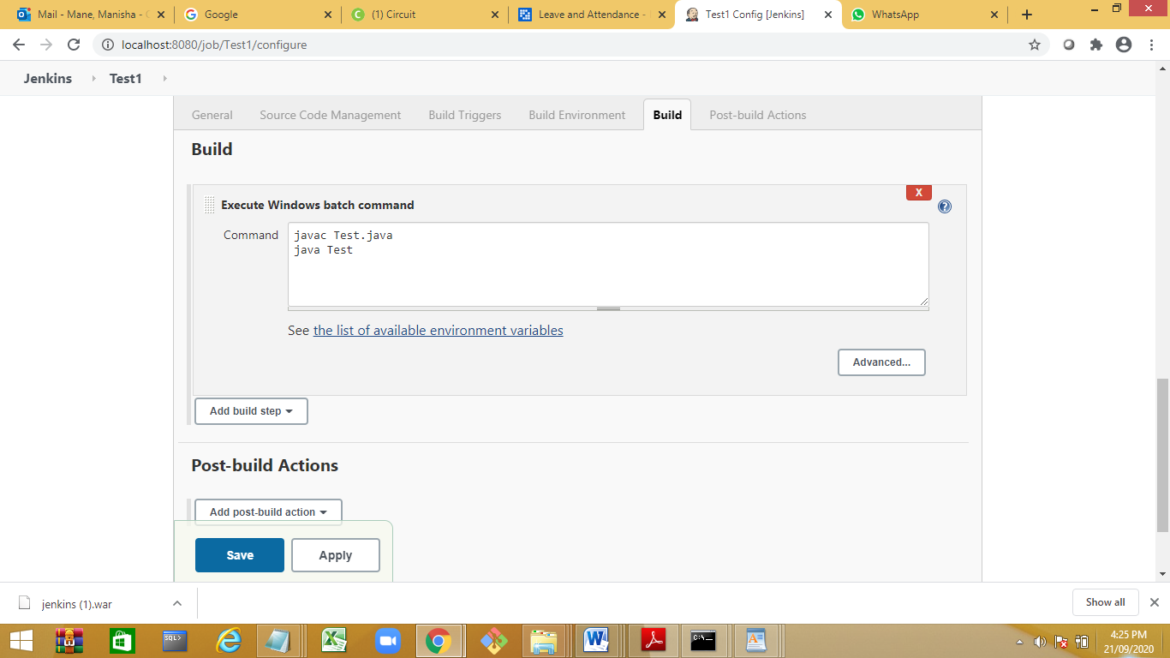

2. Running Jenkins in tomcat

Step 1 : Download Tomcat

Step 2 : Unzip and place tomcat folder at any location

Step 3 : Copy/Place the jenkins.war file inside tomcat/webapps folder

Step 4 : Goto commandpromt (cmd) - windows | terminal - mac

- goto tomcat/bin directory

- make all files executable : chmod +x *.sh

In case of windows this command will not work. This step might not be needed if you are on windows. Else you can right click on the file/folder goto security tab and change the permissions.

Can watch -

TOMCAT - How to install and run on Windows | Change Port | Run app

https://youtu.be/ZIIkrn6LHW0?list=PLh...

*** To change the default port of tomcat modify the D:\softwares\Tomcat 8.0\conf\server.xml file.Change at two places in the connector tag.

Step 5 : Start Tomcat : ./startup.sh

(to shutdown tomcat : ./shutdown.sh)

--in windows use startup command to start and shutdown command to shutdown.

search for the port 8080 change it with any other portno like 8082

in server.xml file on conf folder in tomcat

Step 6 : verify if tomcat started : browser - http://localhost:8080

or

--http://localhost:8082

Step 7 : verify if jenkins is running on tomcat : http://localhost:8080/jenkins

http://localhost:8082/jenkins

*** To start jenkins (standalone) on a diff port***

java -jar jenkins.war --httpPort=9090

problem : if JAVA_HOME or JRE_HOME is not set , the tomacat server will not start.

--Add in the env variable JAVA_HOME=path of jdk (dont include bin)

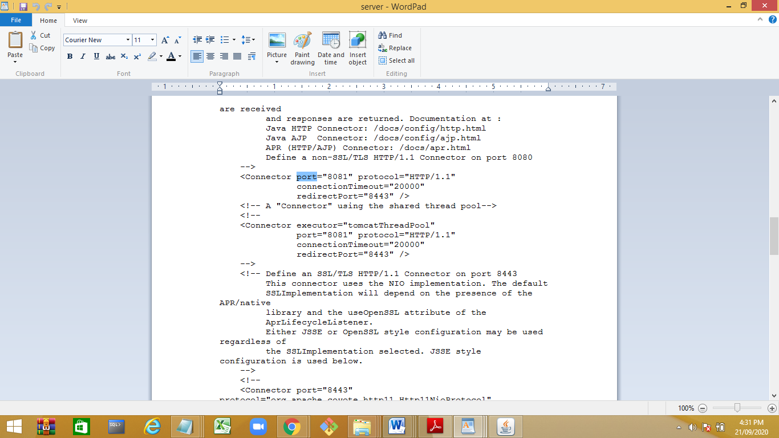

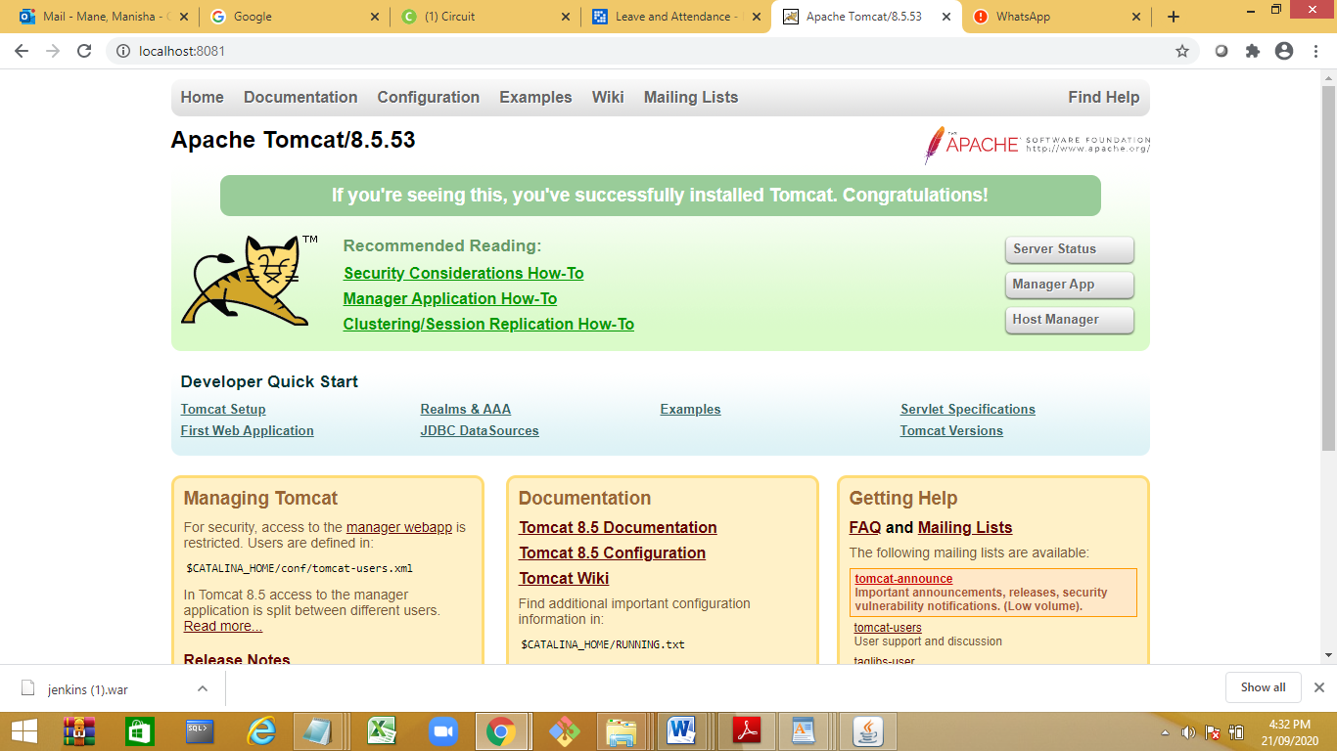

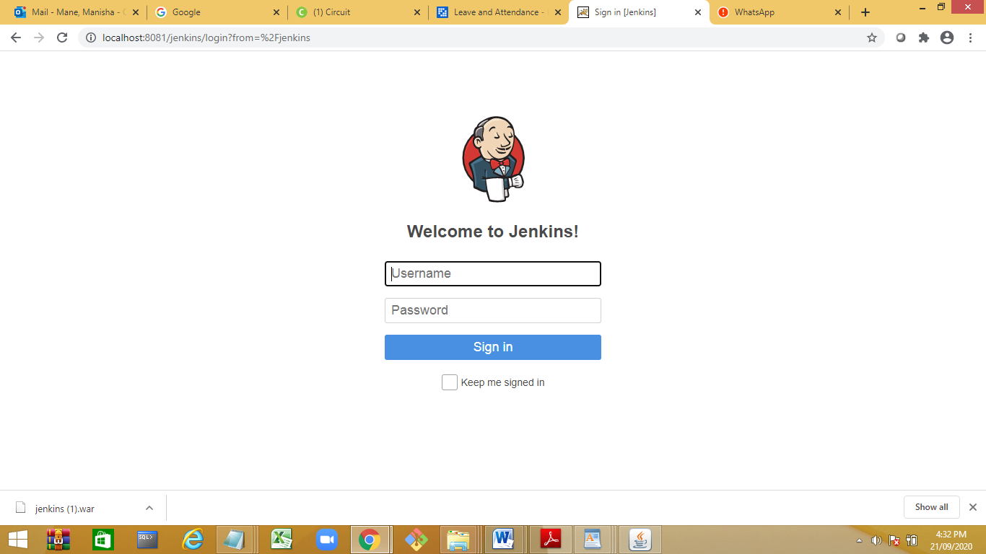

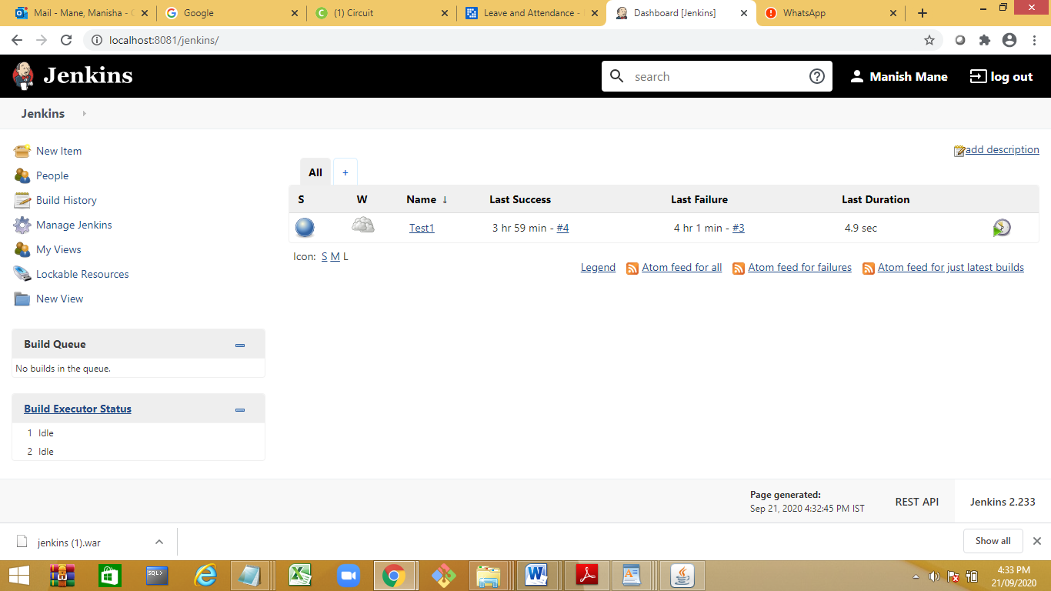

start the tomcat :

set 3paths

JAVA_HOME=” C:\Program Files\Java\jre1.8.0_251”

JRE_HOME=” C:\Program Files\Java\jre1.8.0_251”

System vatiable:

JENKINS_HOME=”

Change Jenkins Home Directory

Identify the drive with large space

Create a folder My_Jenkins

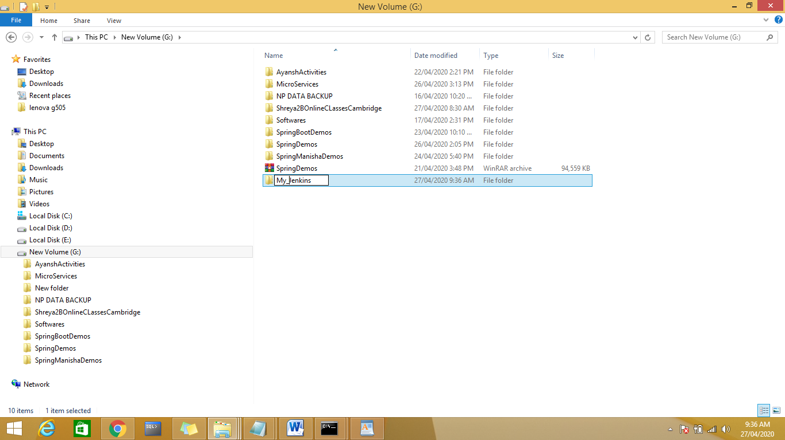

Copy paste the content form

C:\Users\Dell\.jenkins to G:\My_Jenkins

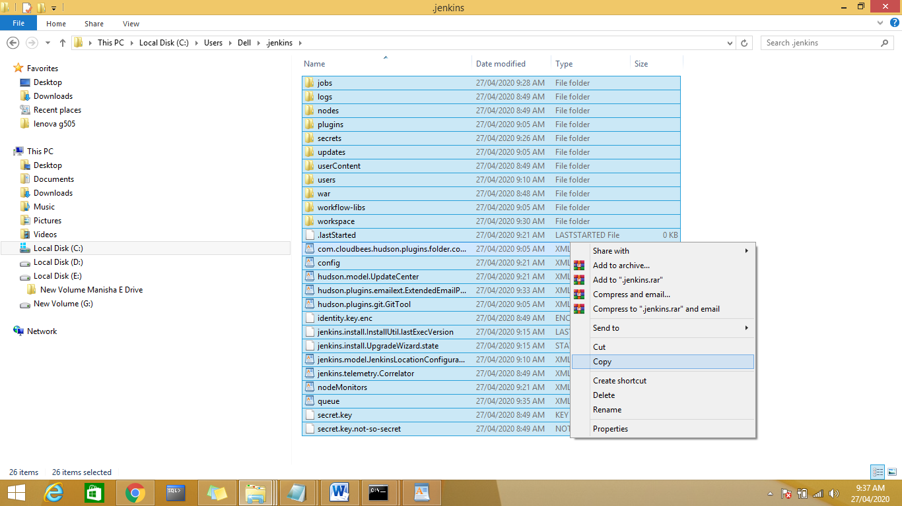

Set JENKINS_HOME= path in system variable

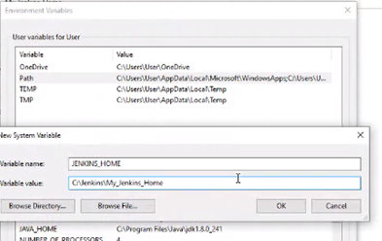

Day 2:

Configuration to display HTML Msg.

ManageJenkins🡪Configure Global Security

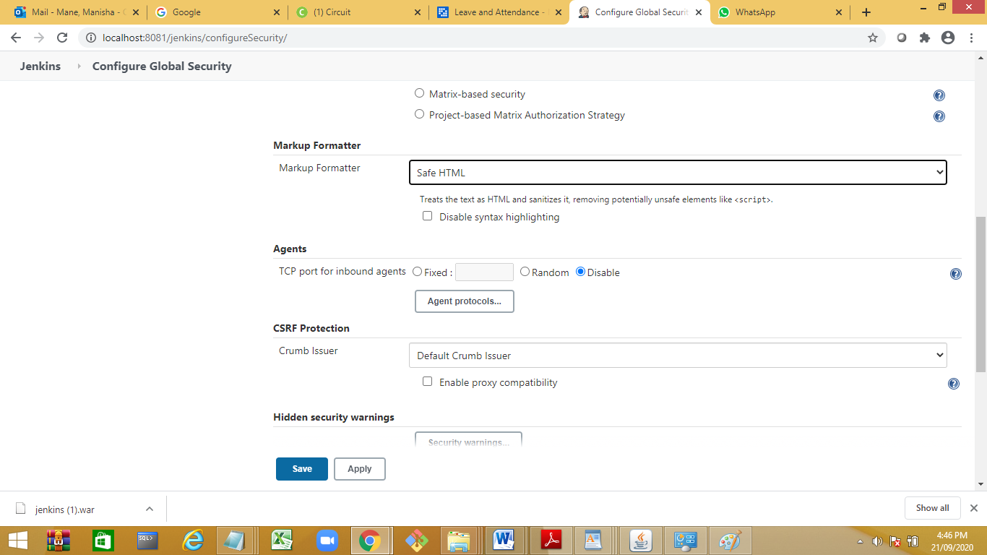

Got Job Jenkins🡪ManageJenkins🡪Configure

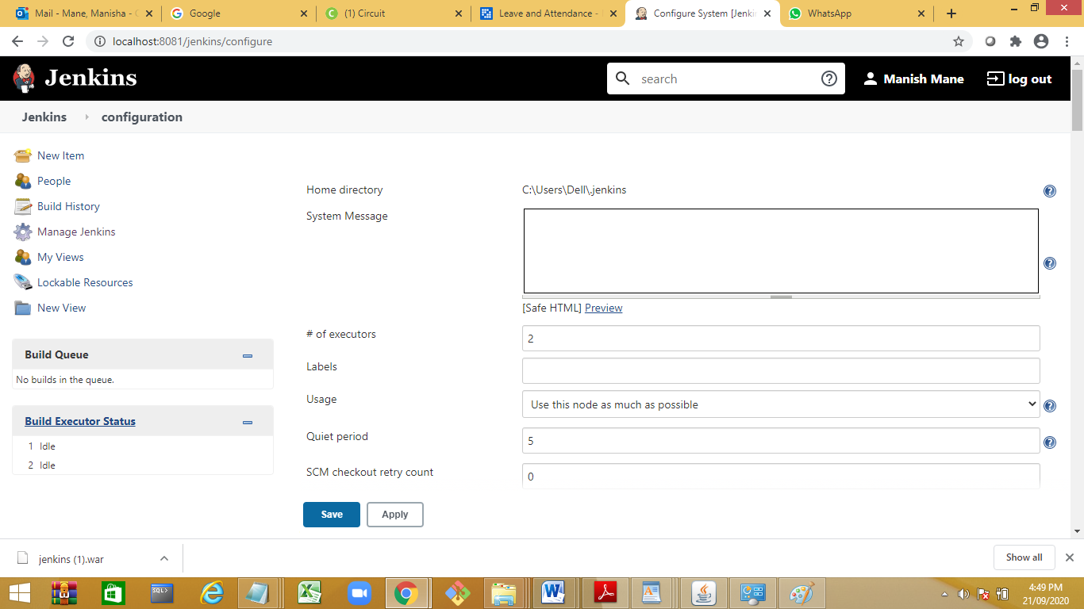

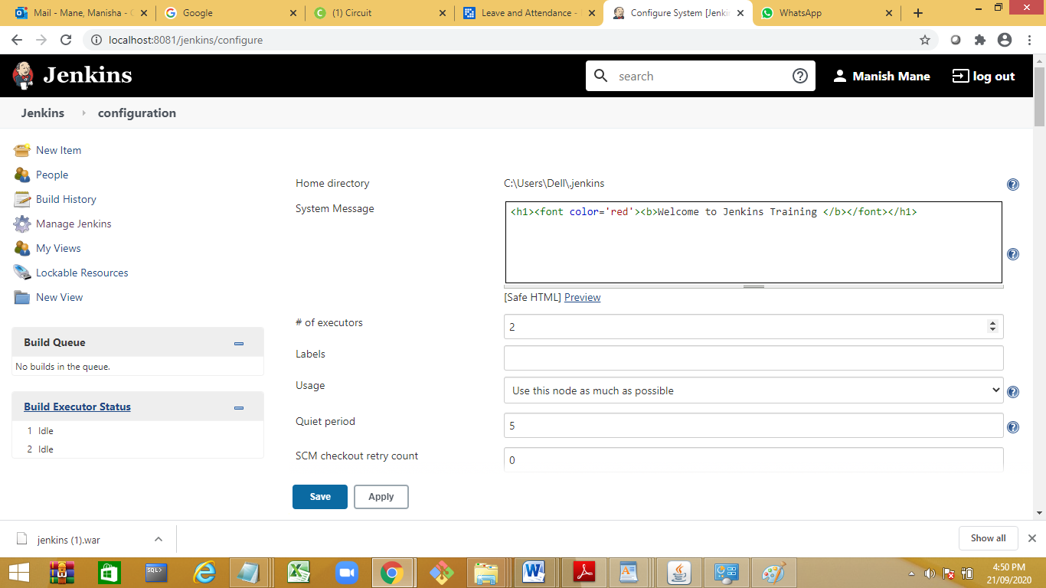

Default Maven repository

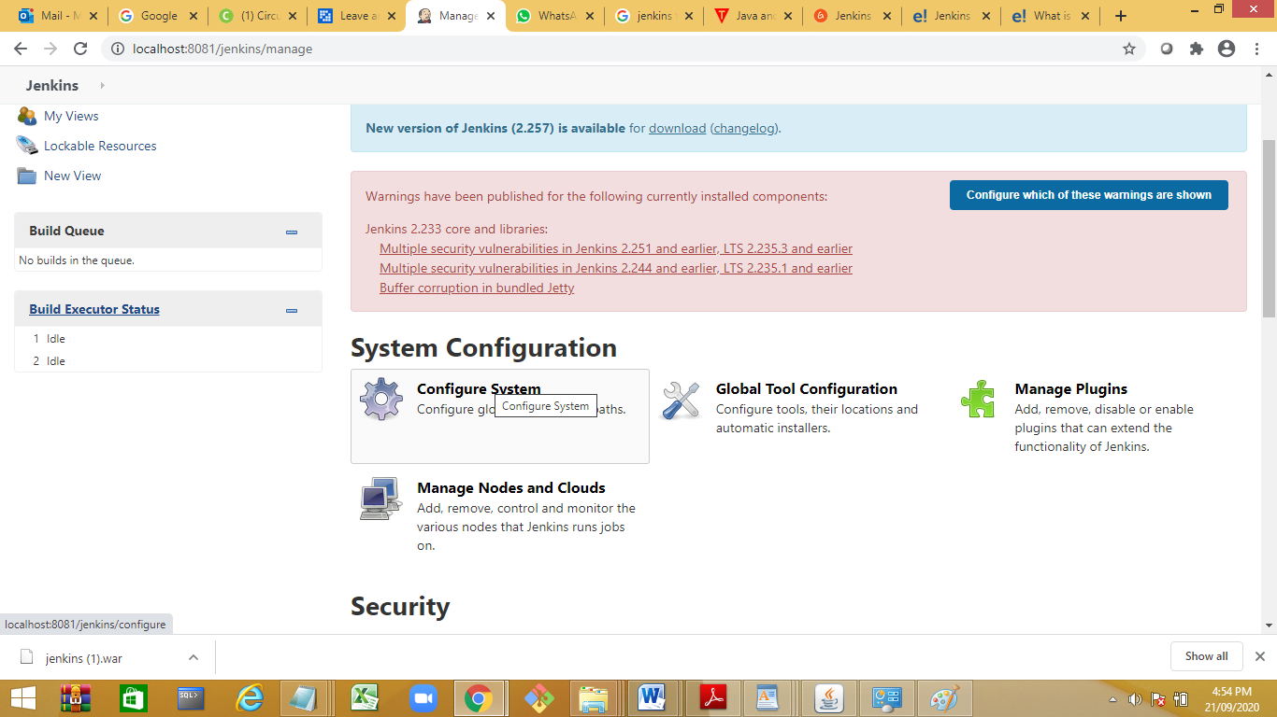

Quite period: time where the Jenkins will wait for its previous action to complete and then start .default is 5 seconds.

Check for Maven Plugins

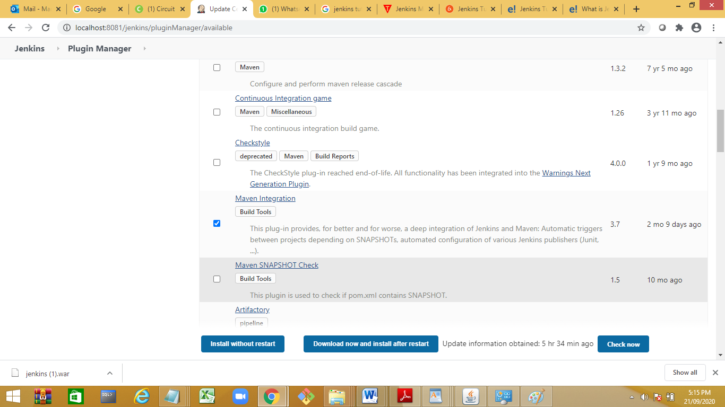

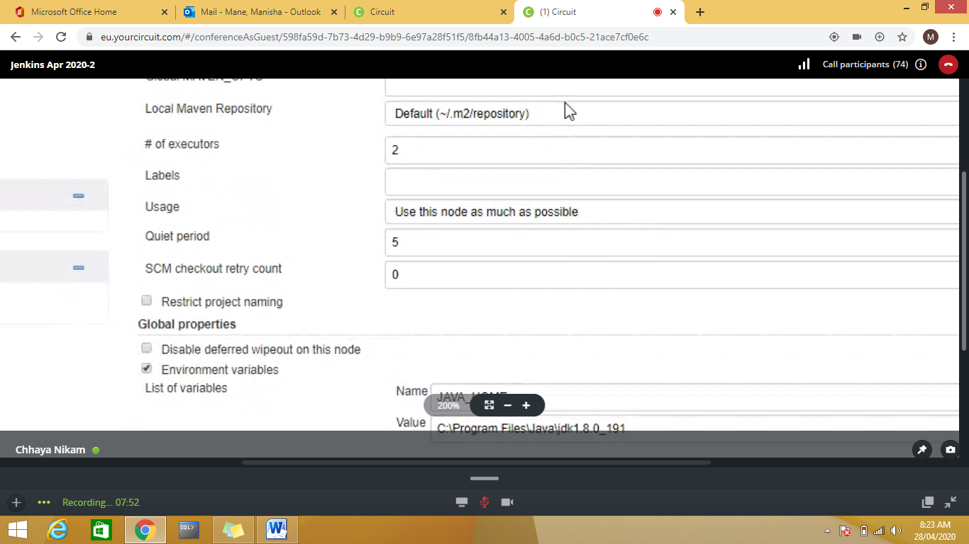

<https://maven.apache.org/download.cgi>.

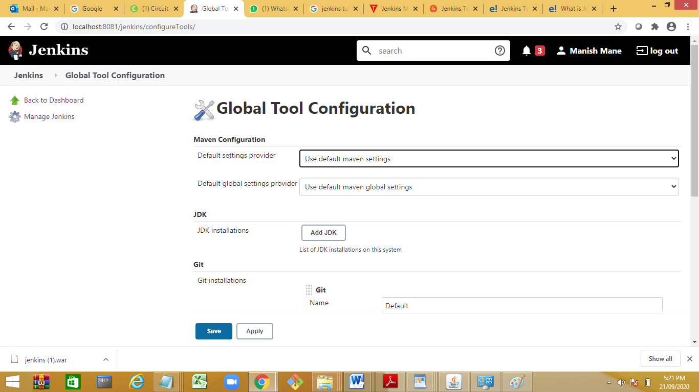

Add JDK

To configure Java, click on "**Add JDK**" button in the JDK section.

Give a **Name** and **JAVA_HOME** path, or check on **install automatically** checkbox.

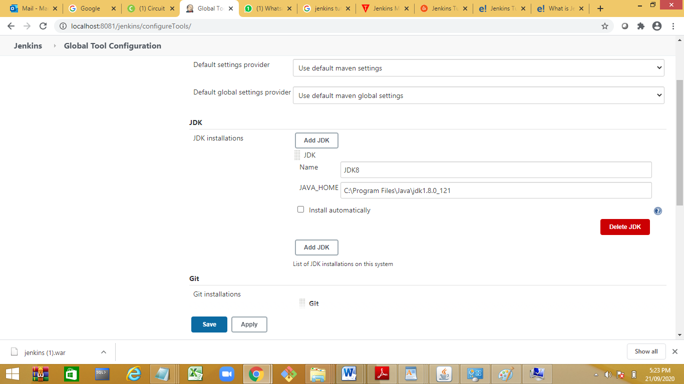

 configure Maven, click on "Add Maven" button in the Maven section, give any **Name** and **MAVEN_HOME** path or check to install automatically checkbox.

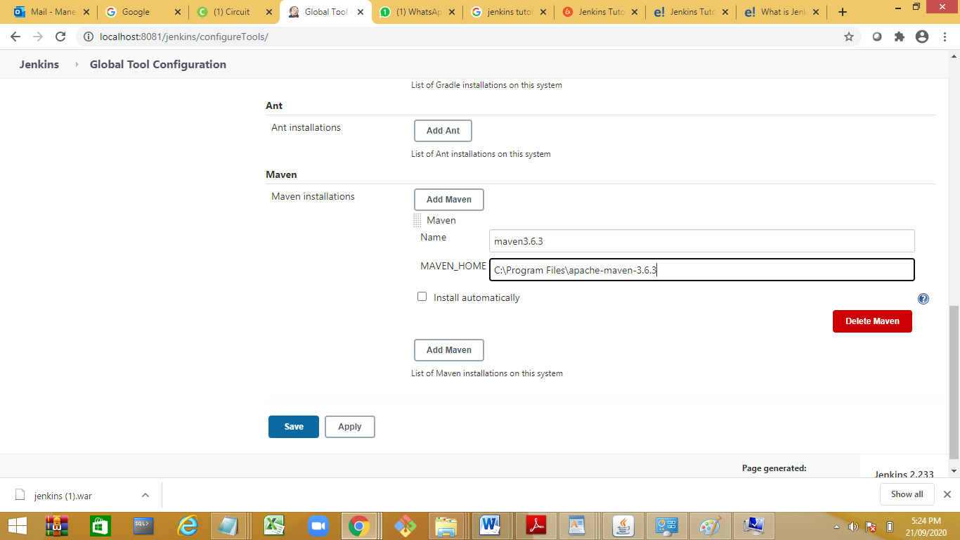

Save The Changes

How to add Plugins: 3 ways to add plugins

Method 1:Jenkins🡪Manage Jenkins

Method 2 :download and do upload file from advance tab

Method 3: download plugins and and copy paste at and restart

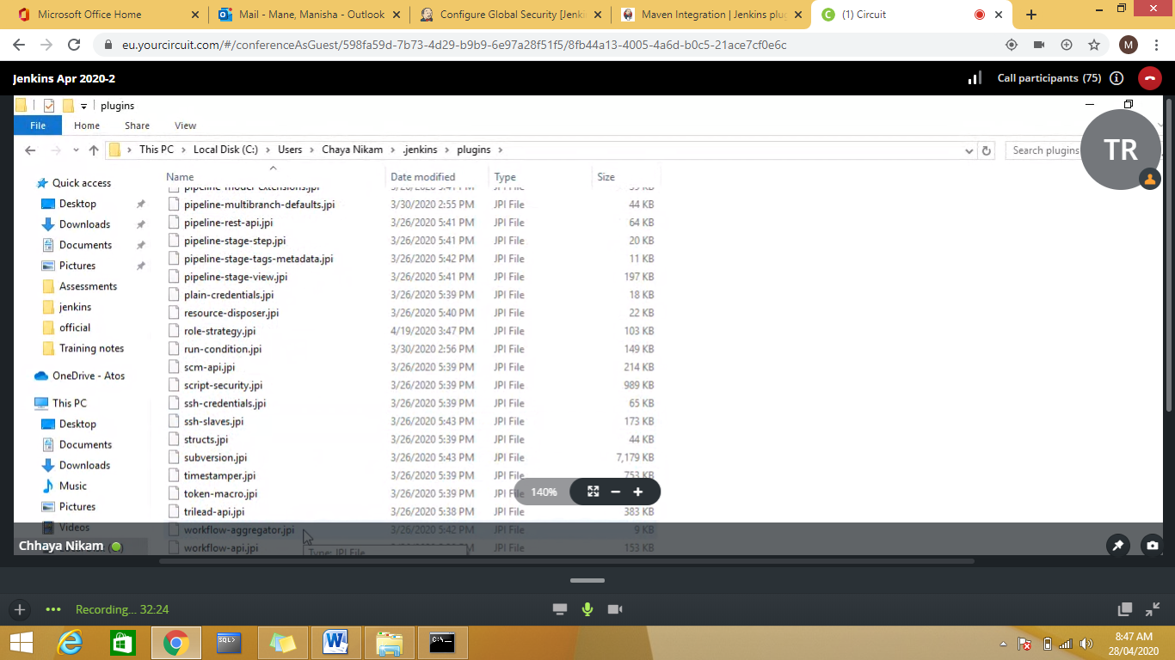

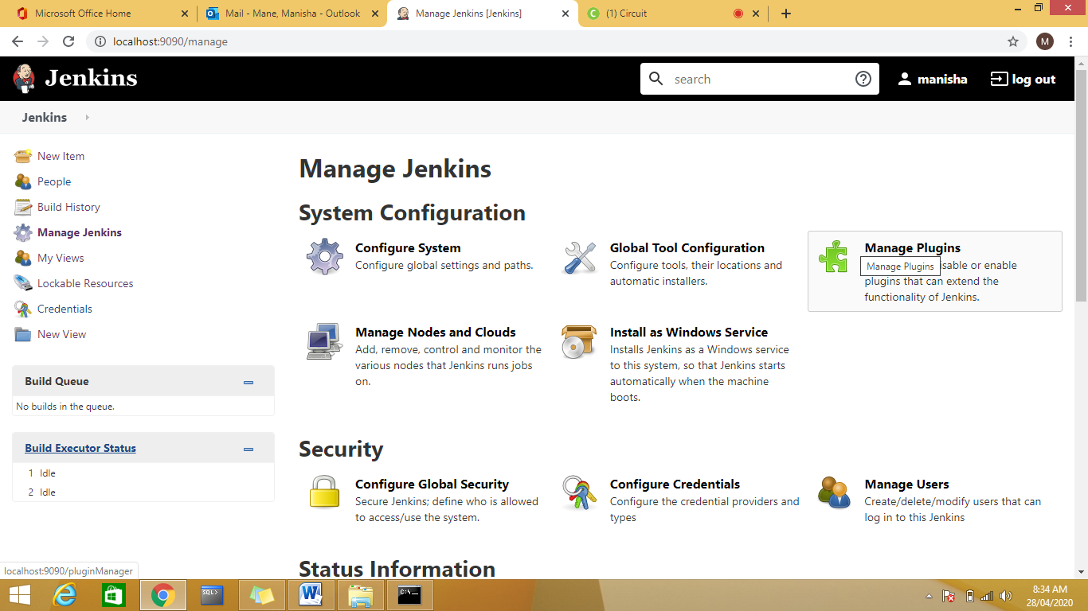

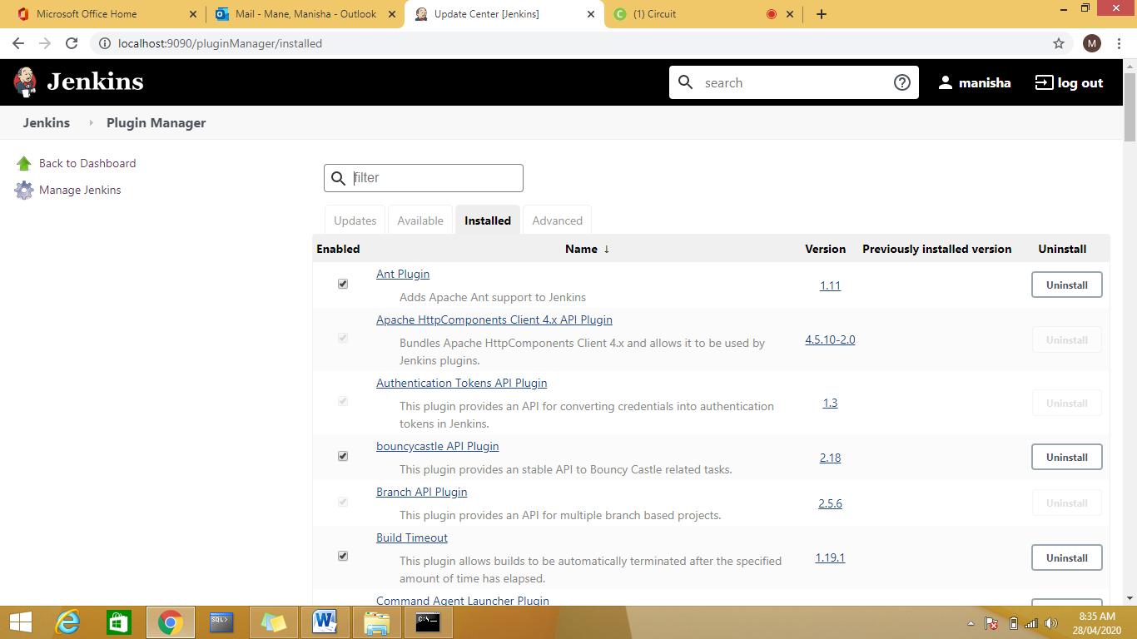

Installed the needed plugin: For example maven integration plugin

## Install Role-based Authorization Strategy Plugin

**Step 1:** Open your Jenkins dashboard by visiting <http://localhost:9090/jenkins>

**Steps 2:** Click on '**Manage Jenkins**' and select the '**Available**' tab.

Authentication and Authorization

1. Add Role based security plugin
2. 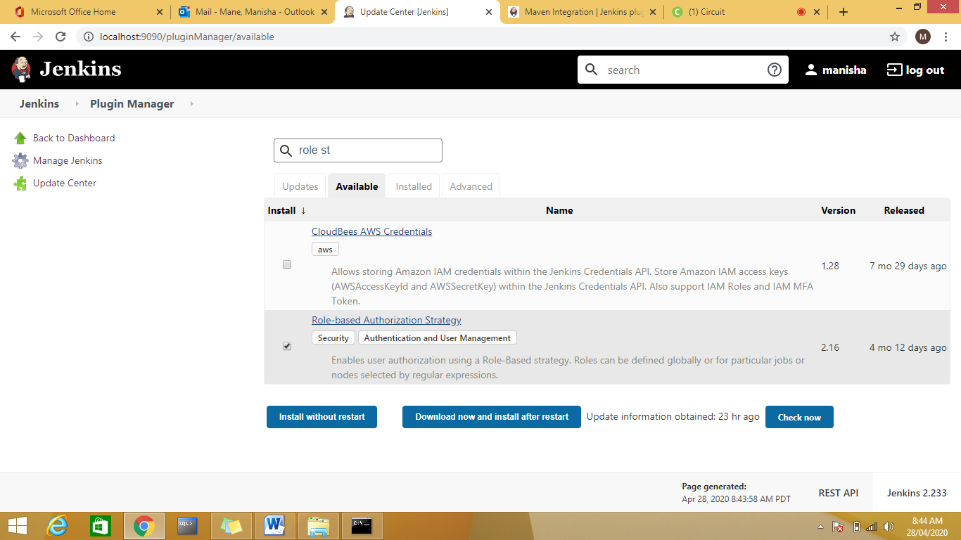

Install plugins

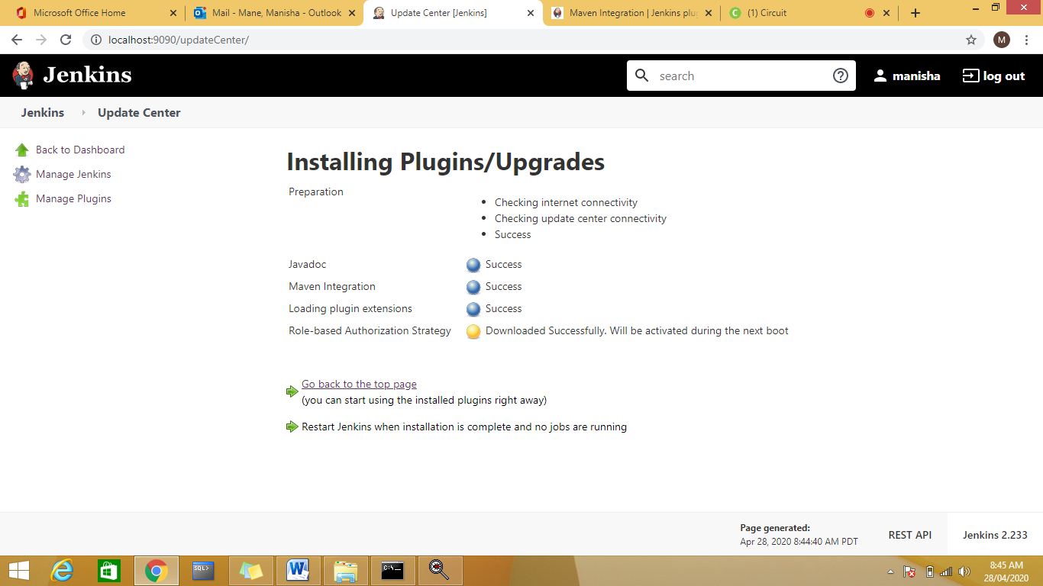

After plugin installation Role Based Strategy will be available

)

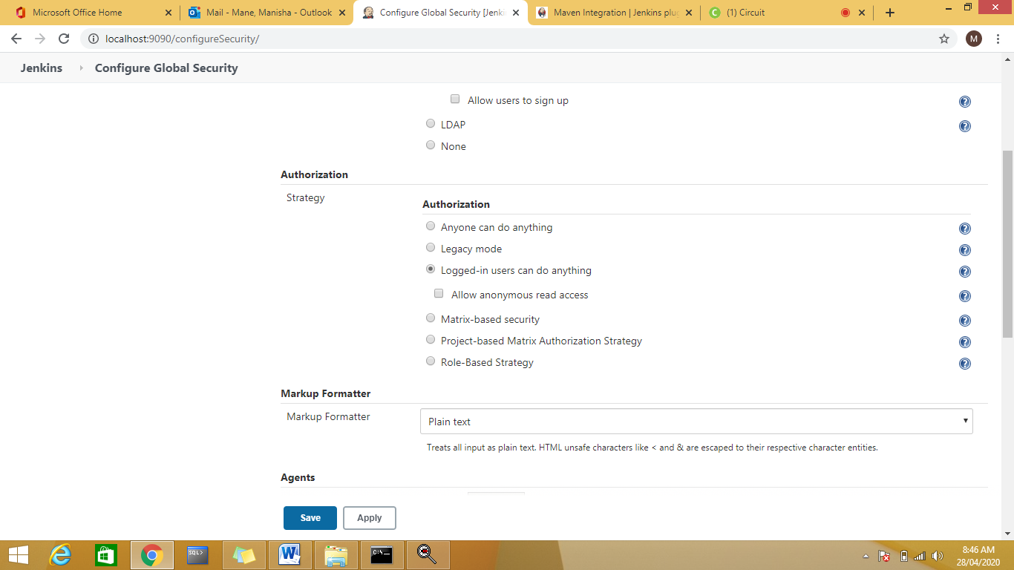

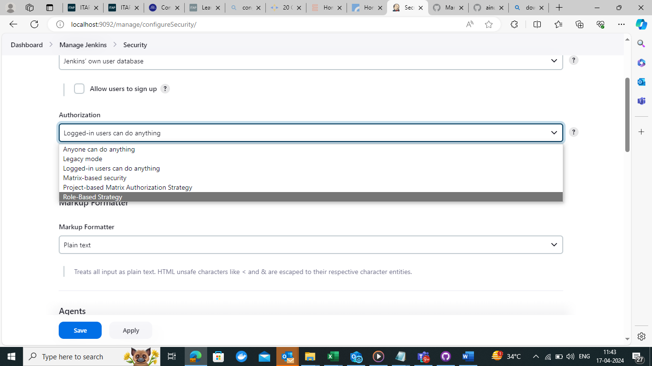

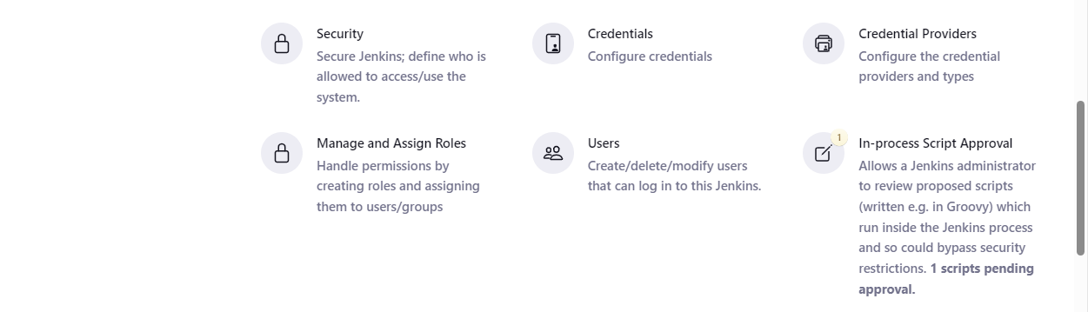

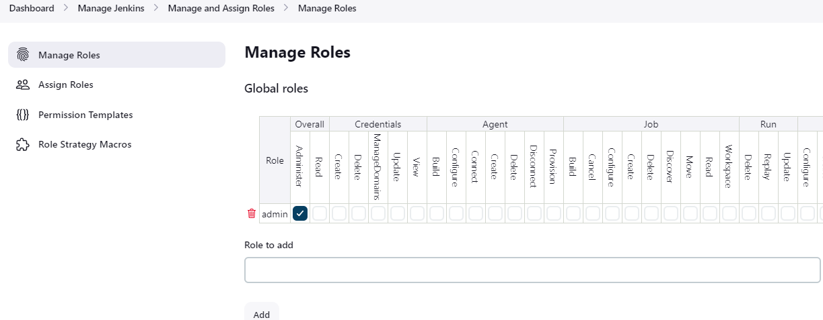

Authentication and Authorization

Create 2 Users: dev and test

Jenkins🡪Manage Users

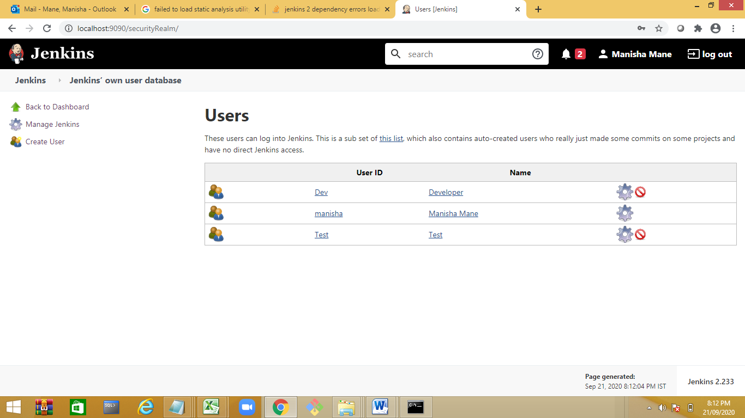

Authorization : Creating roles (Role Based shd be selected )

## Enable Role-Based Strategy on Jenkins

**Step 1:** After Plugin installation, go to the 'Manage Jenkins' and then click on '**Configure Global Security**'.

[**next →**](https://www.javatpoint.com/jenkins-pipeline)[**← prev**](https://www.javatpoint.com/jenkins-management)

# Create and Manage Users in Jenkins

Generally, in a large organization, there are multiple separate teams to run and manage jobs in Jenkins. But managing this crowd of users and assigning roles to them is too difficult.

By default, when you create a user in Jenkins, it can access almost everything. In this, you can create multiple users but can only assign the same global roles and privileges to them. This is not ideal, especially for large organizations.

To enable you to assign different roles and privileges to different users in Jenkins, you should have to install the **Role Strategy Plugin**.

## Install Role-based Authorization Strategy Plugin

**Step 1:** Open your Jenkins dashboard by visiting <http://localhost:8080/jenkins>

**Steps 2:** Click on '**Manage Jenkins**' and select the '**Available**' tab.

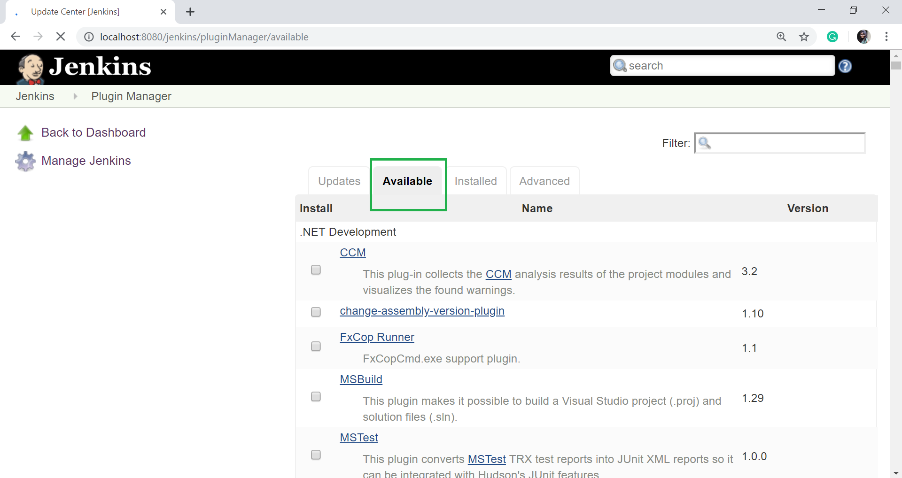

**Step 3:** On the filter option, type "role-based" and press Enter.

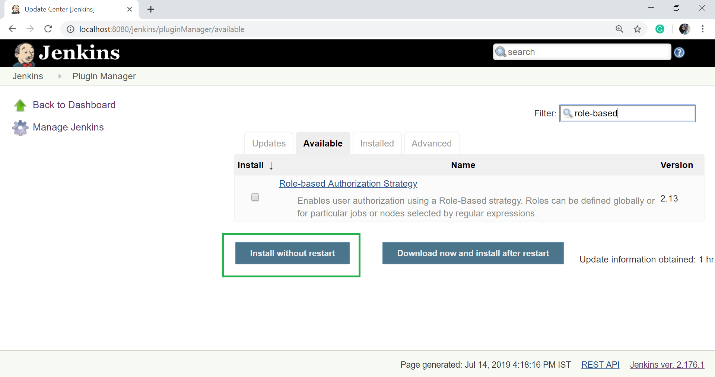

**Step 4:** Now, select the plugin and click on '**Install without restart**' button.

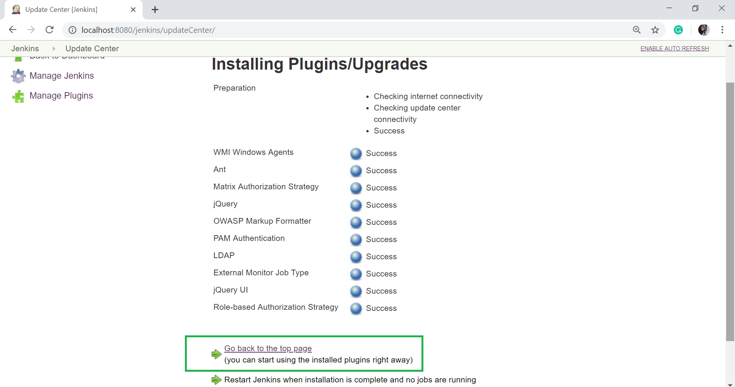

**Step 5:** Click on '**Go back to the top page**'.

## Enable Role-Based Strategy on Jenkins

**Step 1:** After Plugin installation, go to the 'Manage Jenkins' and then click on '**Configure Global Security**'.

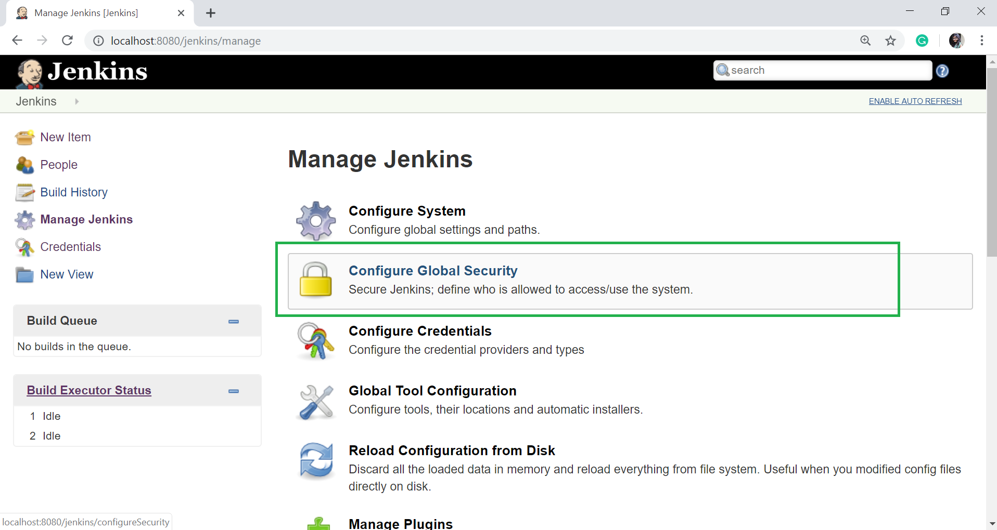

When you click the Configure Global Security option then you will see the following page:

Check on **Enable security** option.

**Step 2:** On the Security Realm section, select '**jenkins' own user database**'.

* On Authorization section, select '**Role-Based Strategy**'.

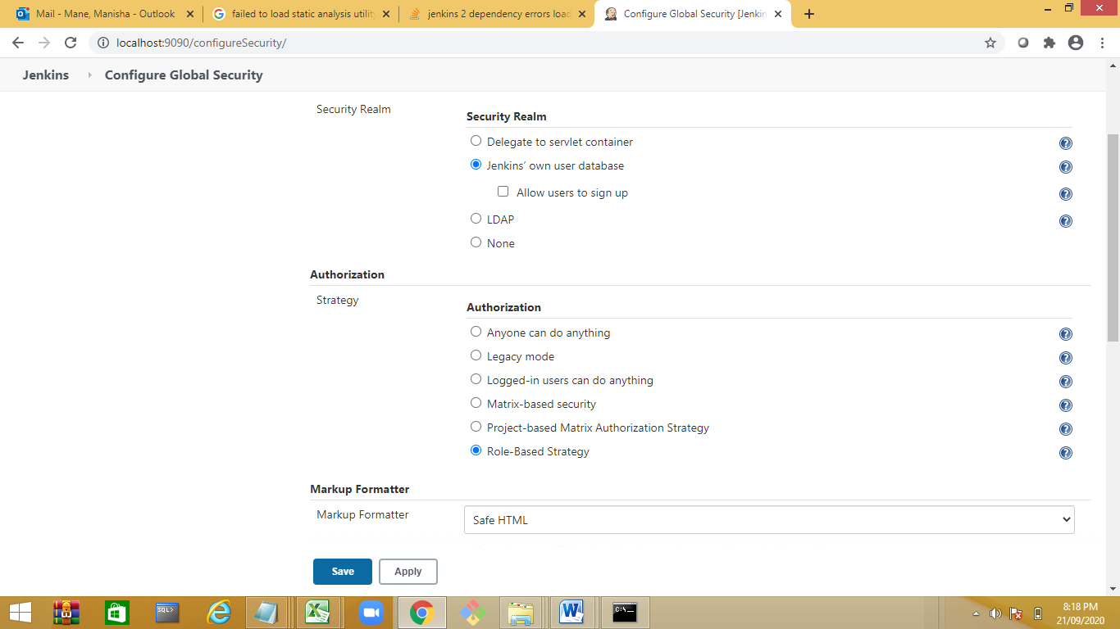

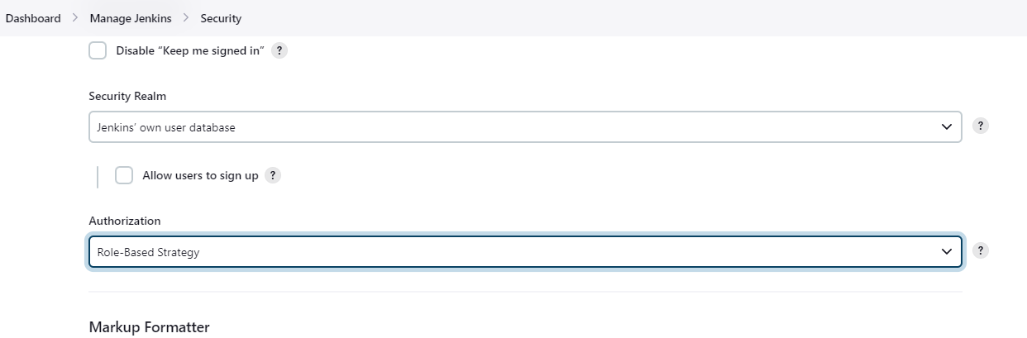

Jenkins🡪Manage and Assign Roles 🡪Manage Roles

Managing User Roles on Jenkins

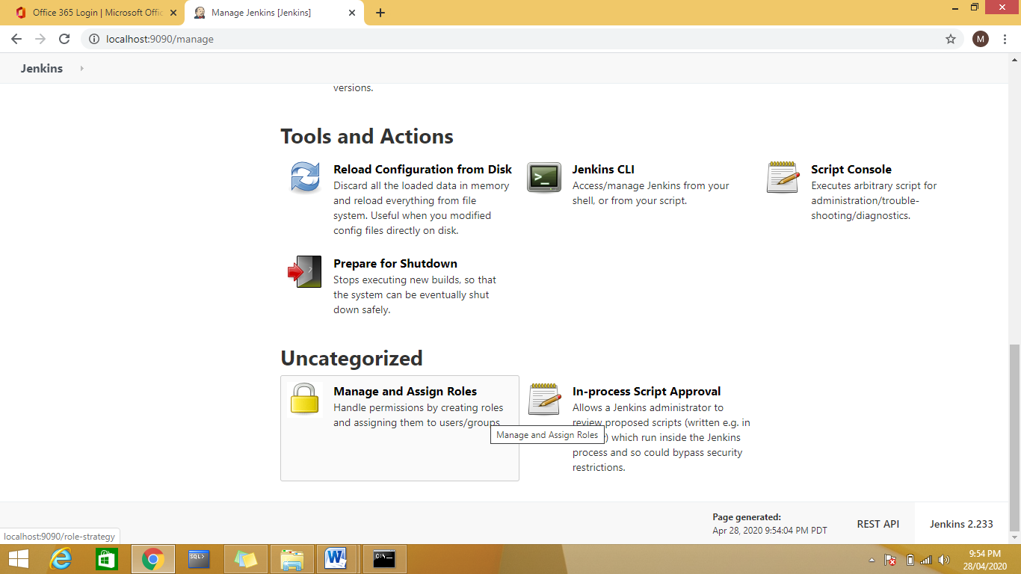

**Step 1:**

* Click on **Manage Jenkins**.
* Select **Manage and Assign Roles**. Note that, Manage and Assign Role will only be visible if you have installed the Role strategy plugin.

**Step 2:** To create a new role called "developer".

* Type "developer" in the **Role to add** option.
* Click on **Add** to create a new role.
* Now, select the appropriate permissions that you want to assign to the developer role.
* Then Click on **Save** button.

2 types of roles global and project specific roles:

Add a new global role as Employee

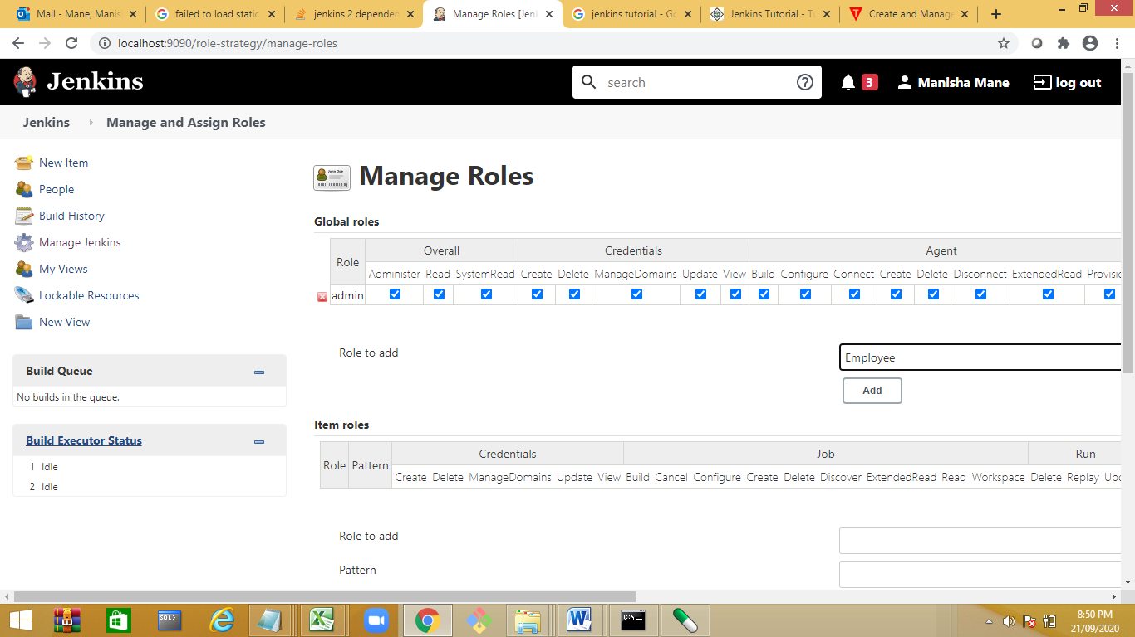

Give read access to employee

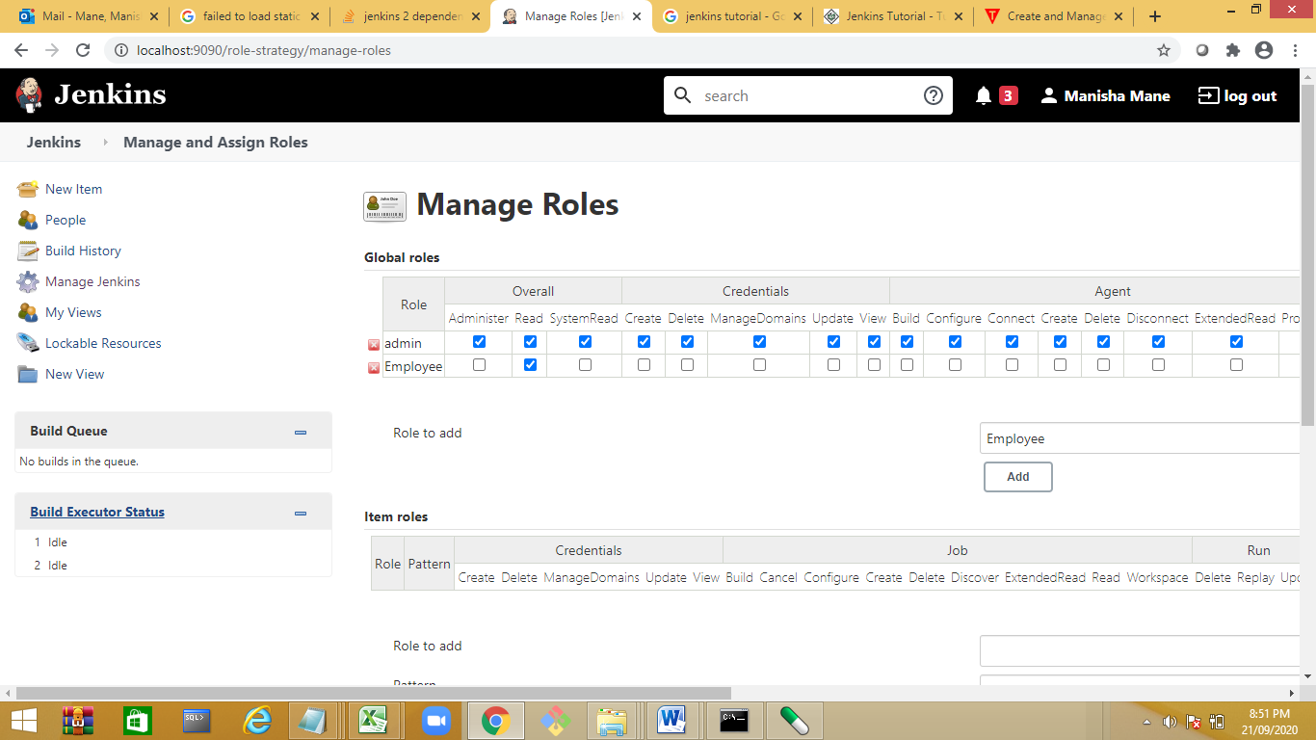

Create 2 roles as developer and tester

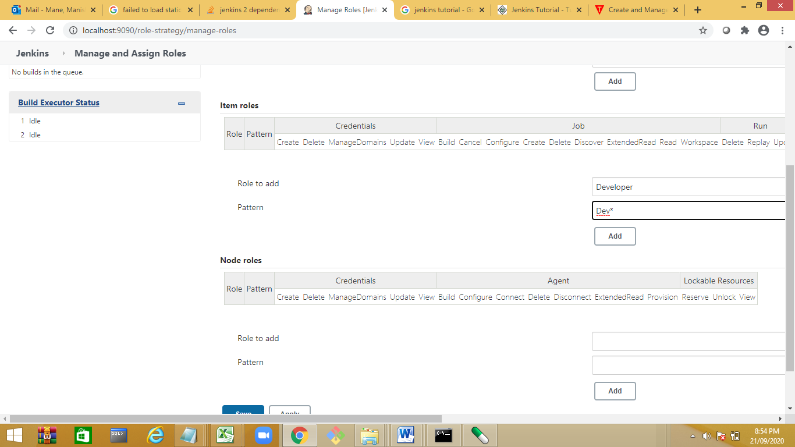

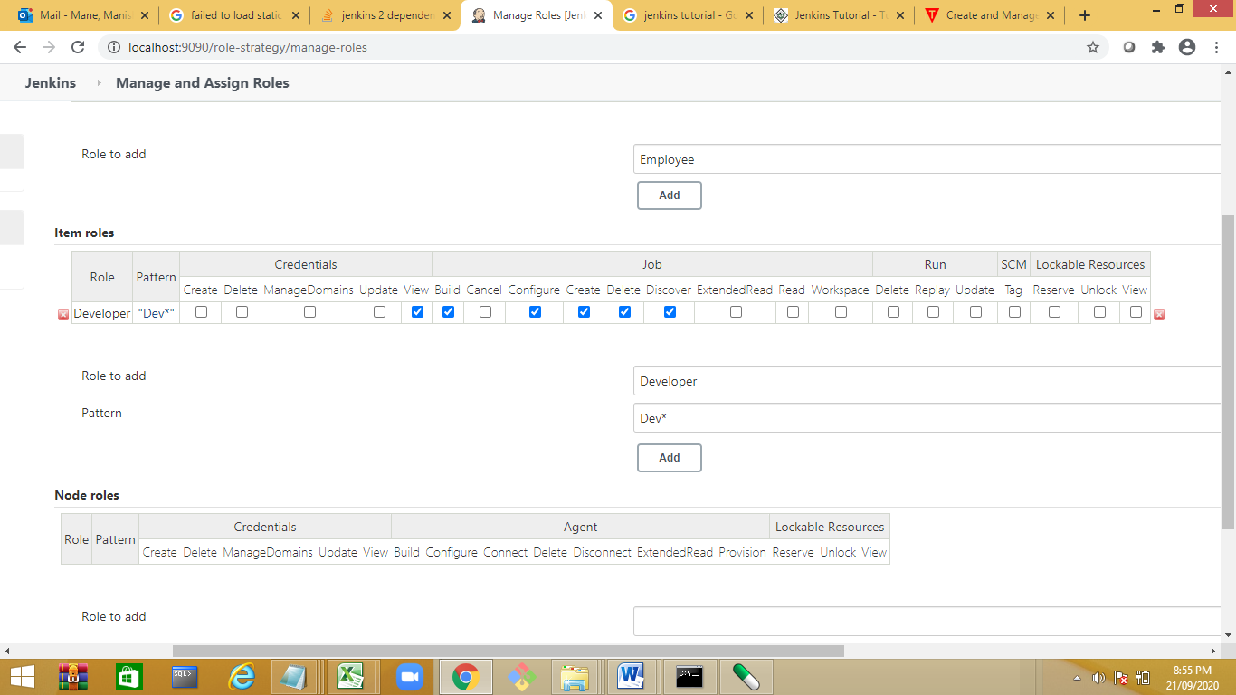

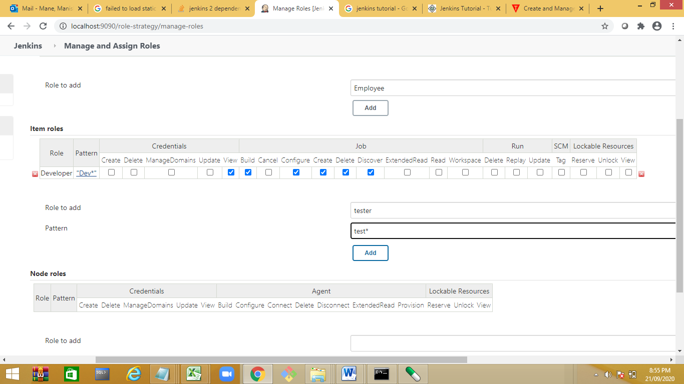

Assign Roles to User Dev and Test

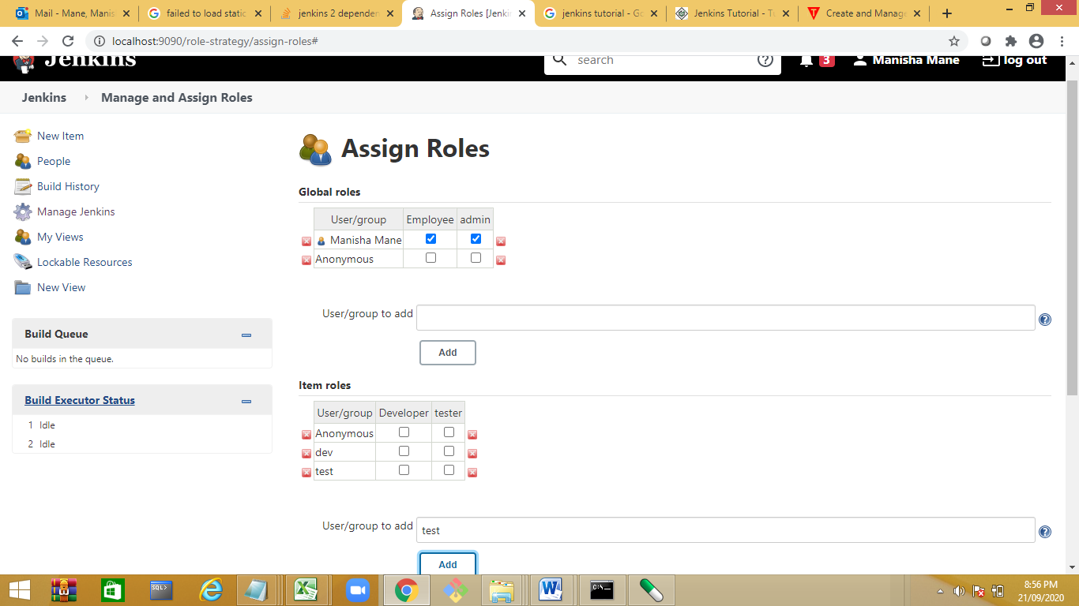

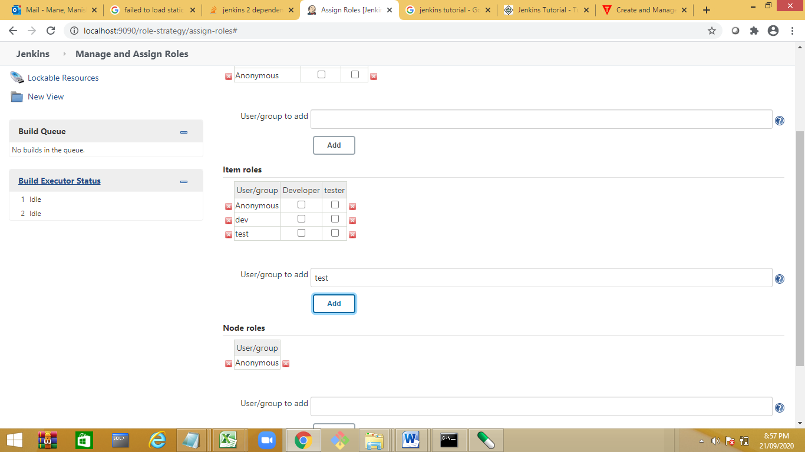

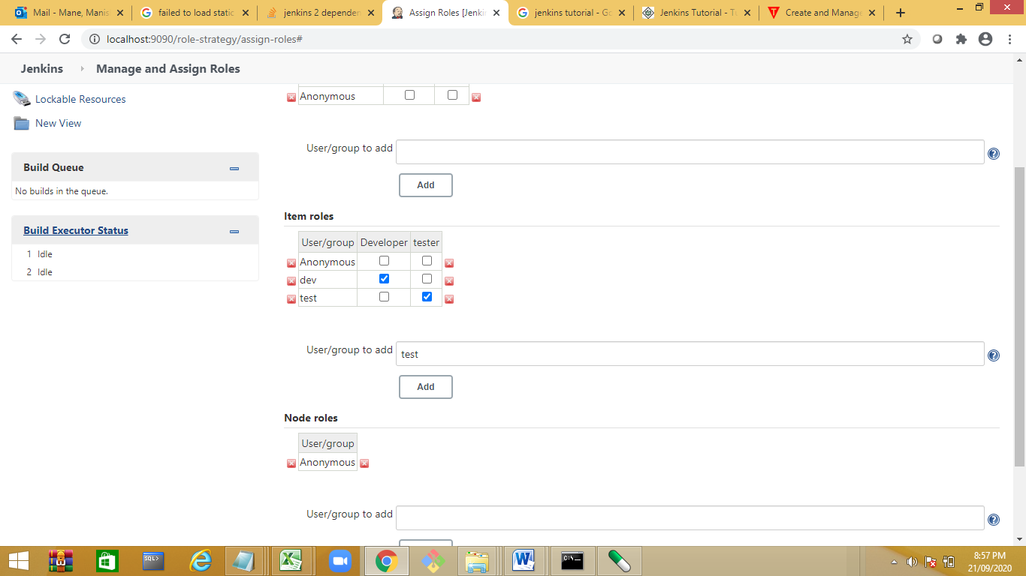

Create 2 Jobs In Admin User

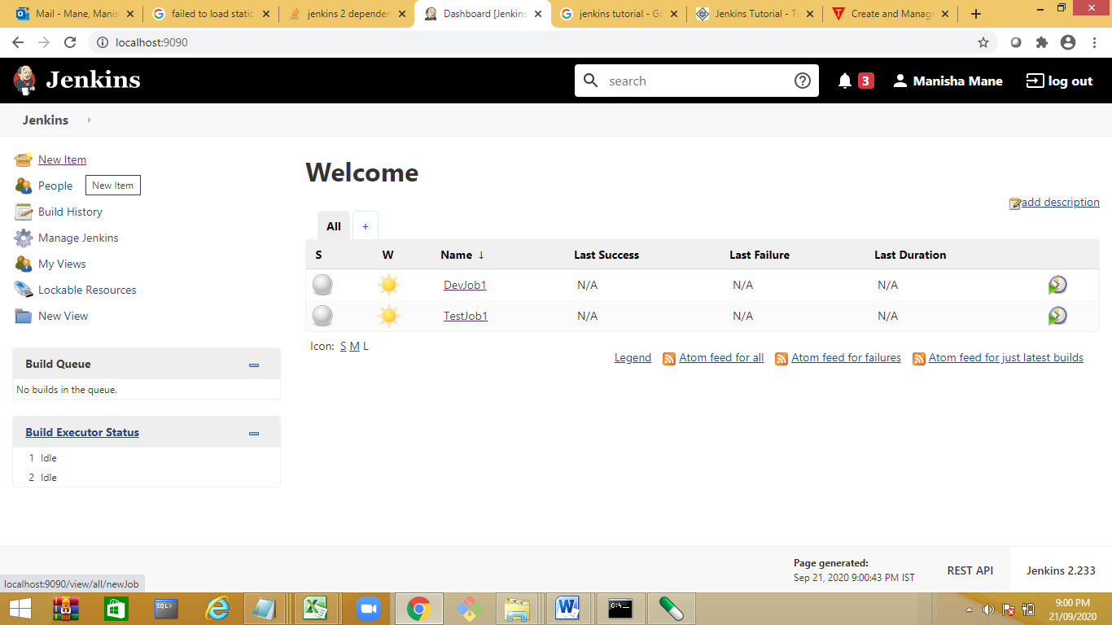

Status

s🡪success

gred out – not build

red 🡪failure

yellow started–successful

whether report 🡪tells about the stability

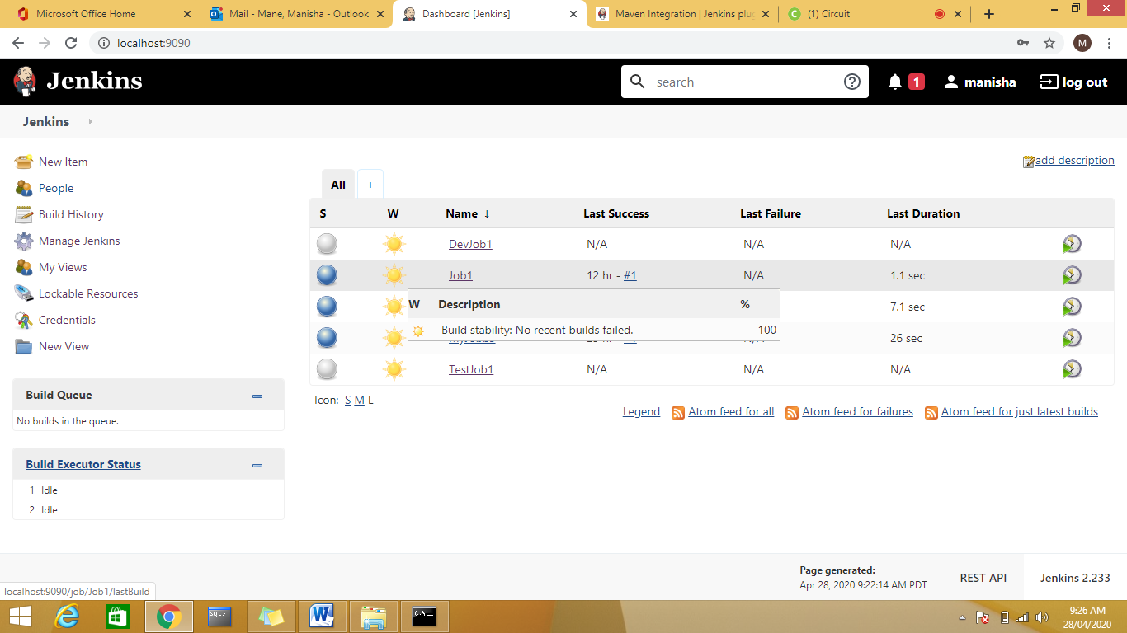

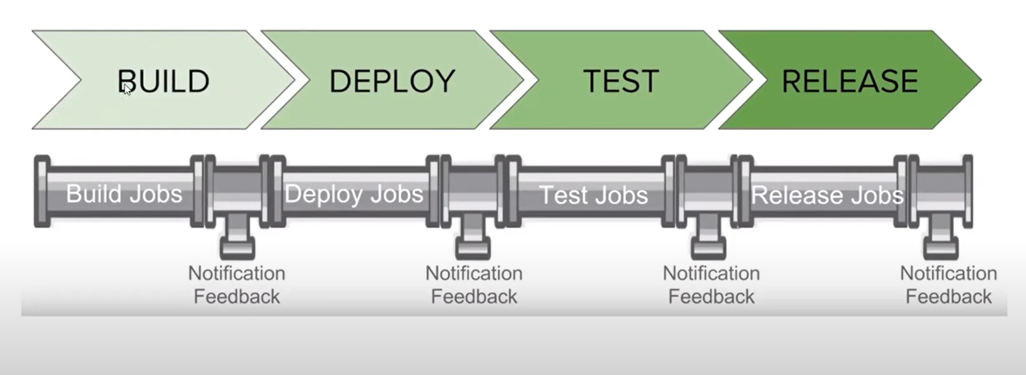

Day 3:

Jenkins Job to pull data from remote repository:

Create a new Job as GitHubPullJob

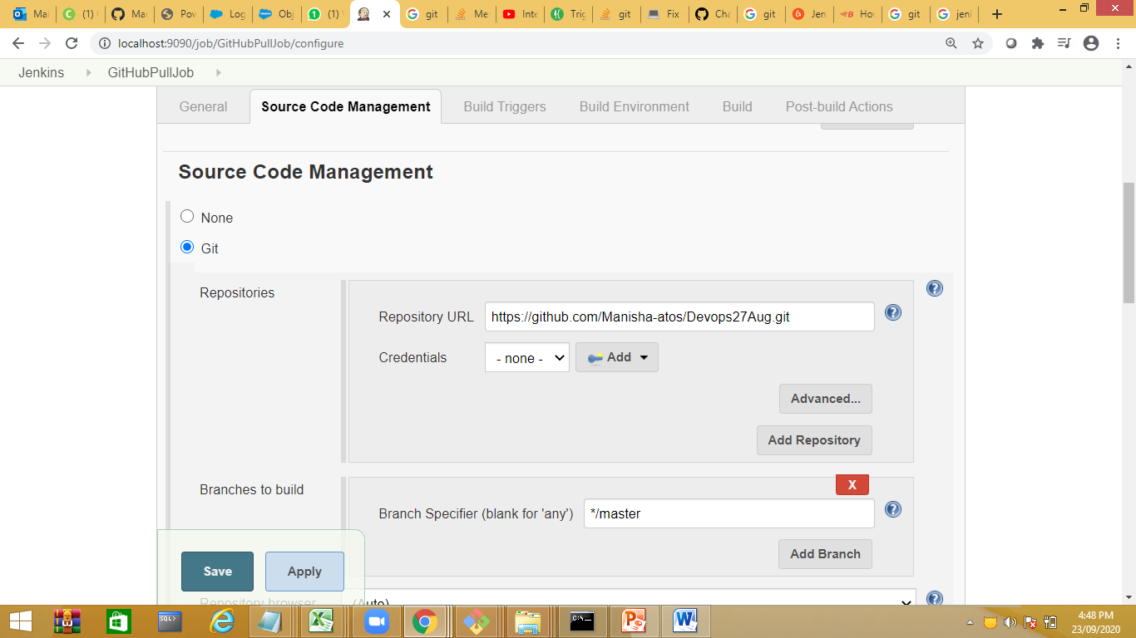

Save and build the job

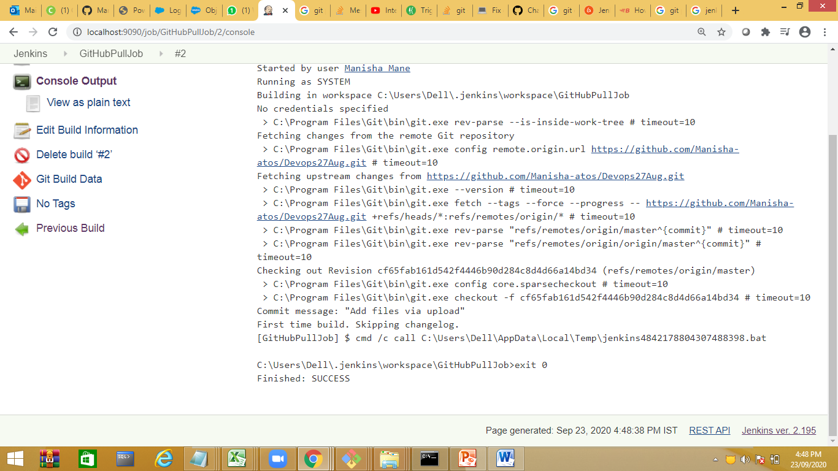

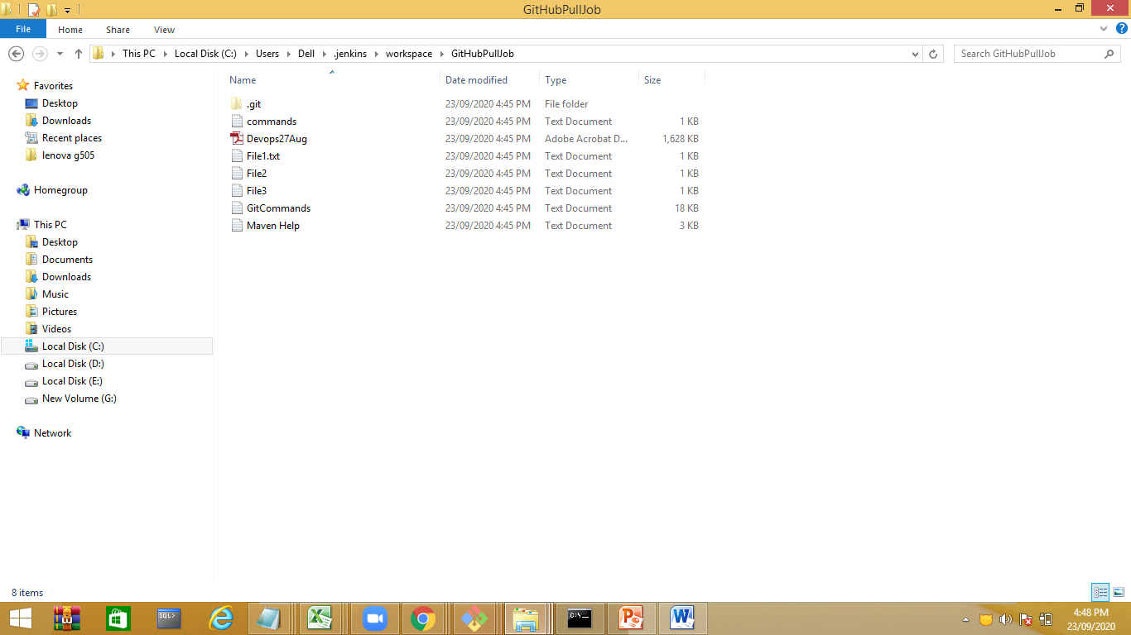

Job to push local repository to remote repository

Jenkins🡪Global Tool Configuration

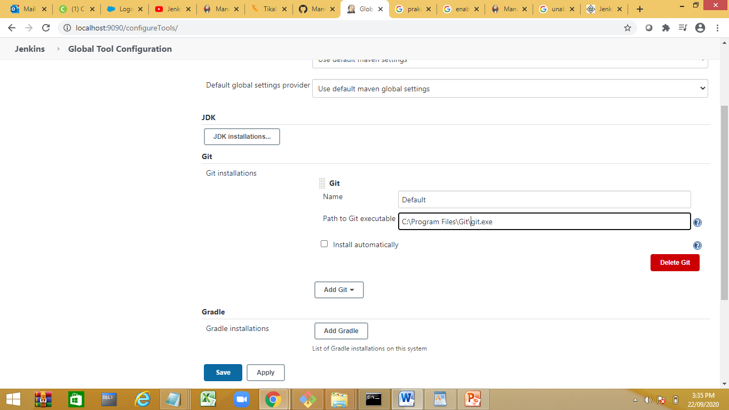

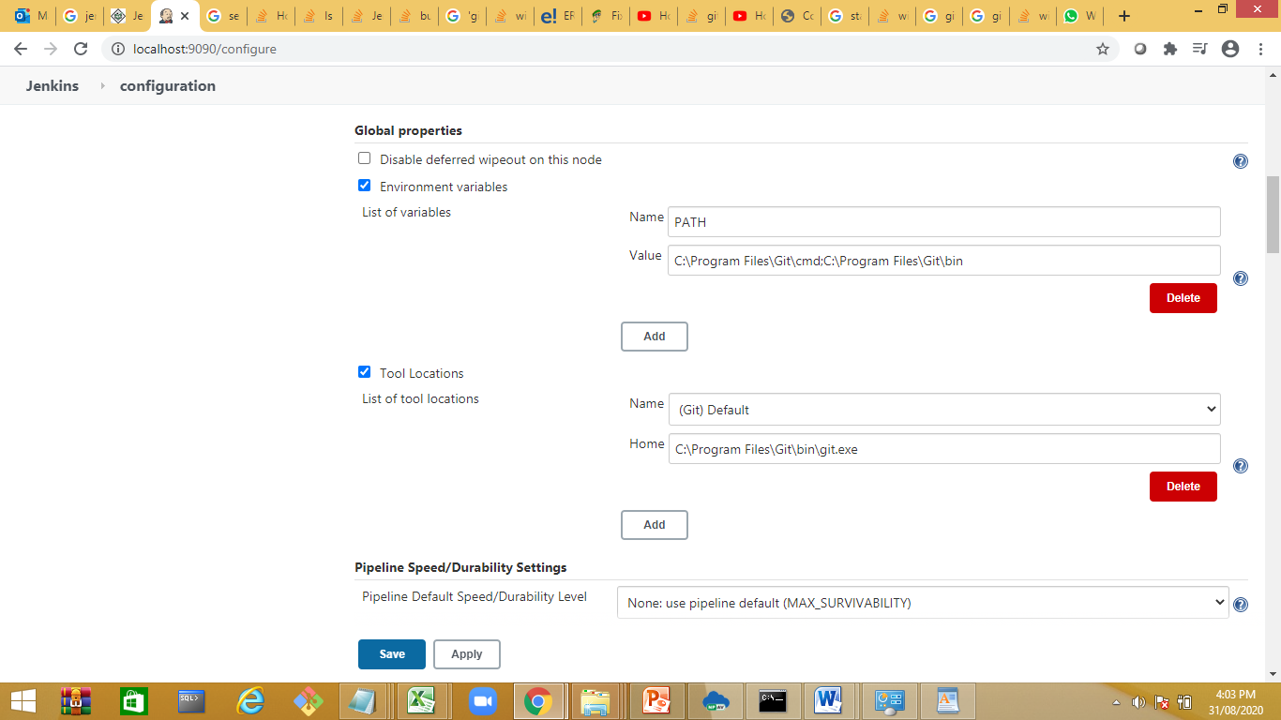

Create a new Job GitPushJob

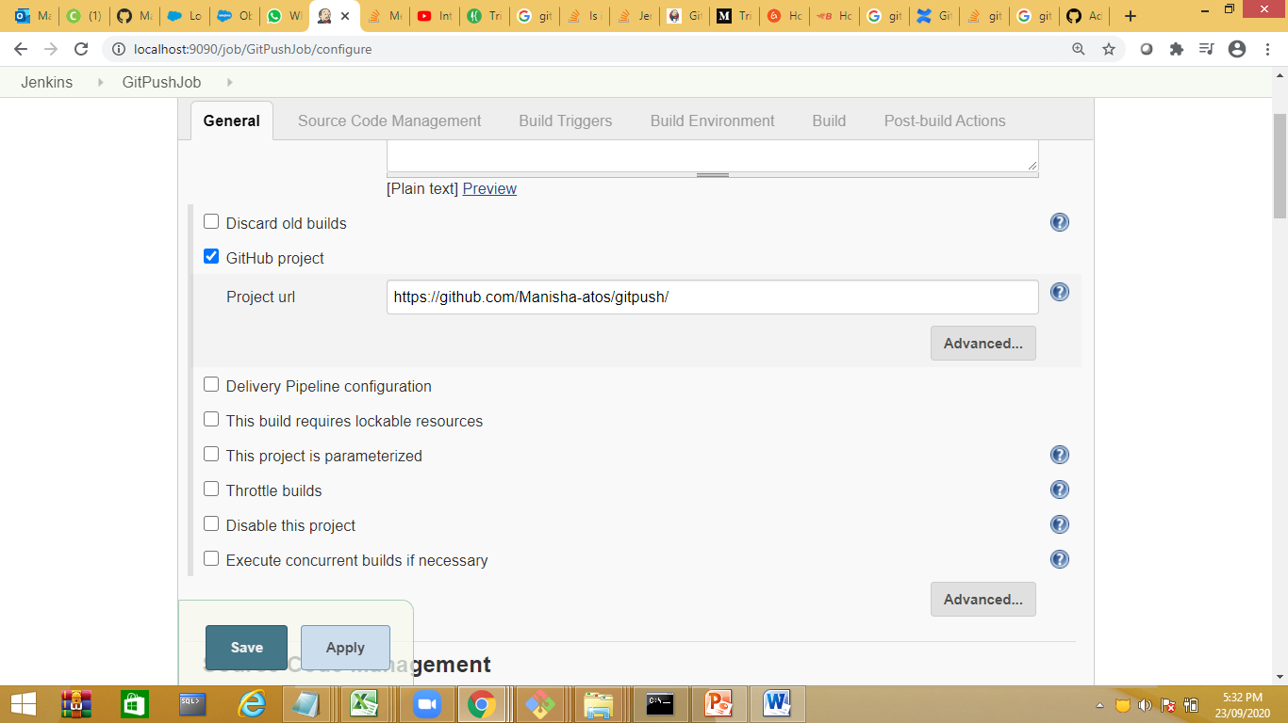

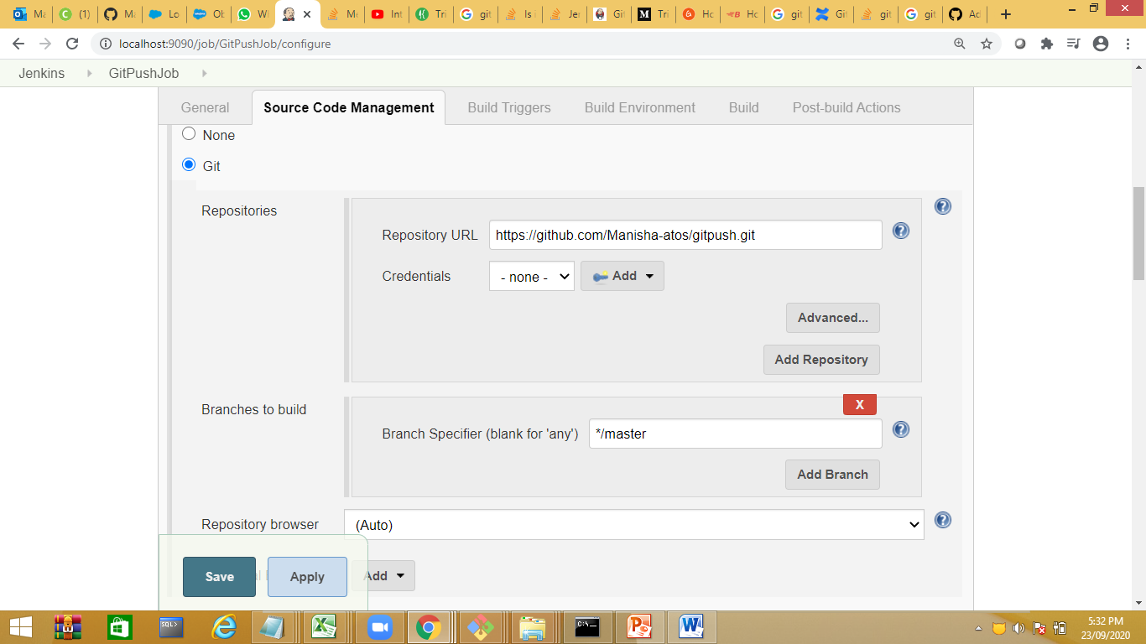

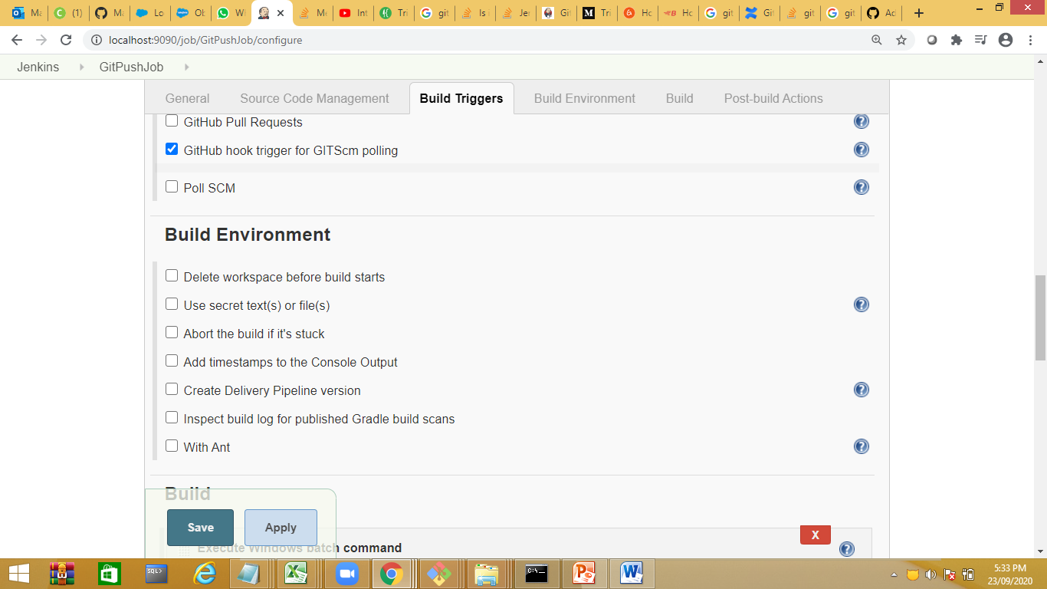

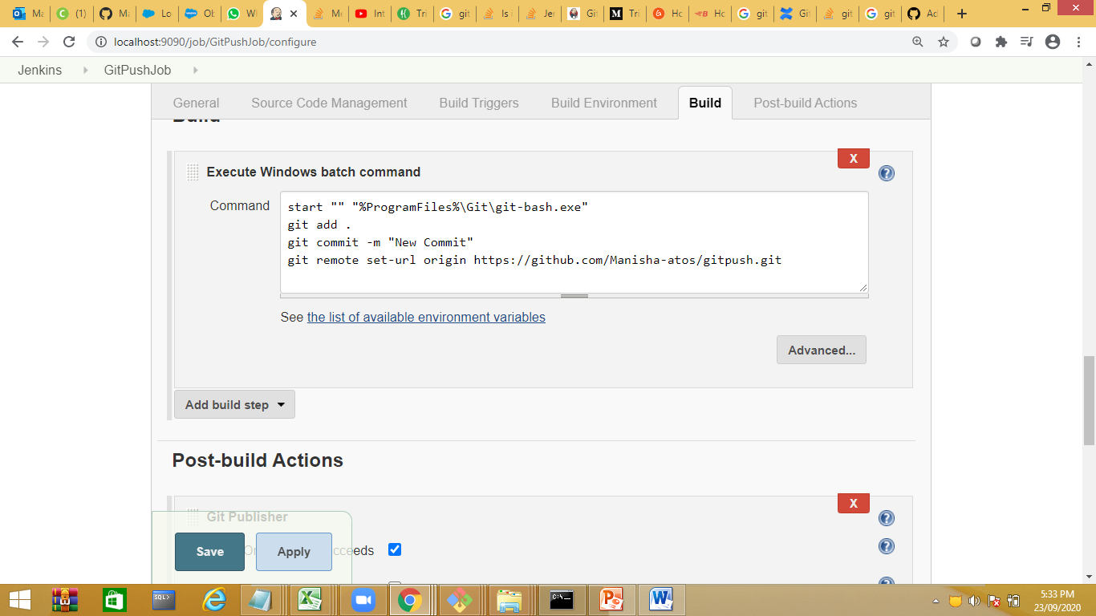

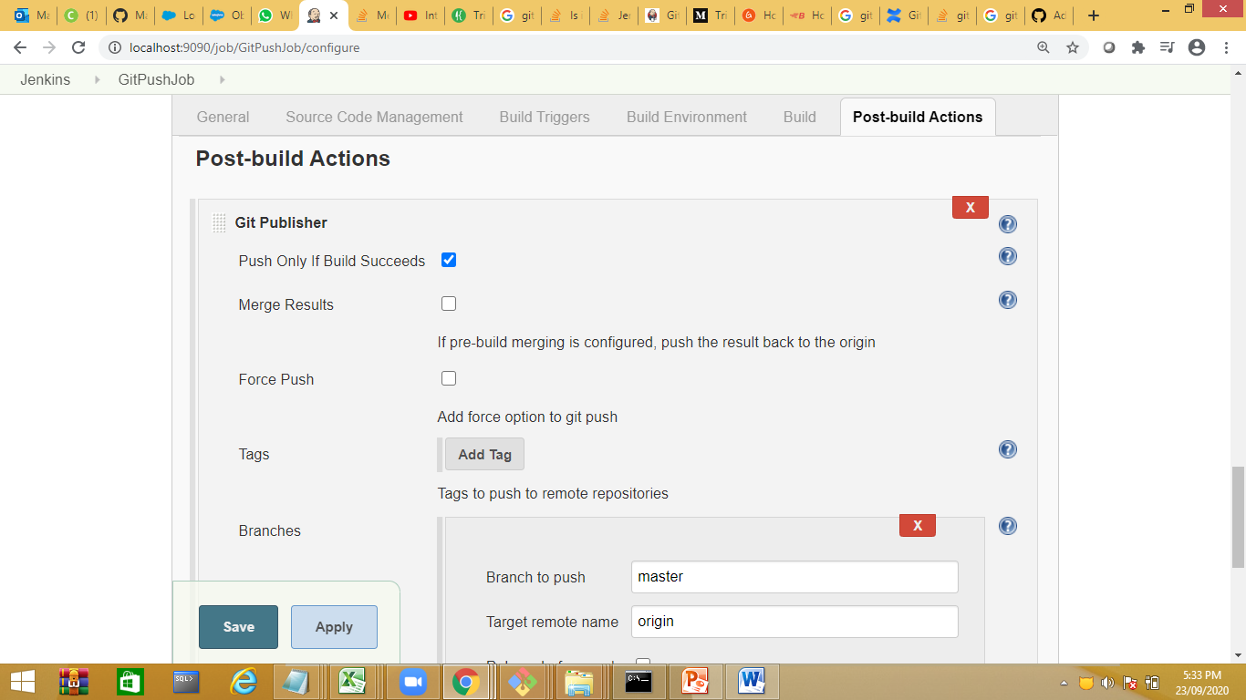

Save the job and run

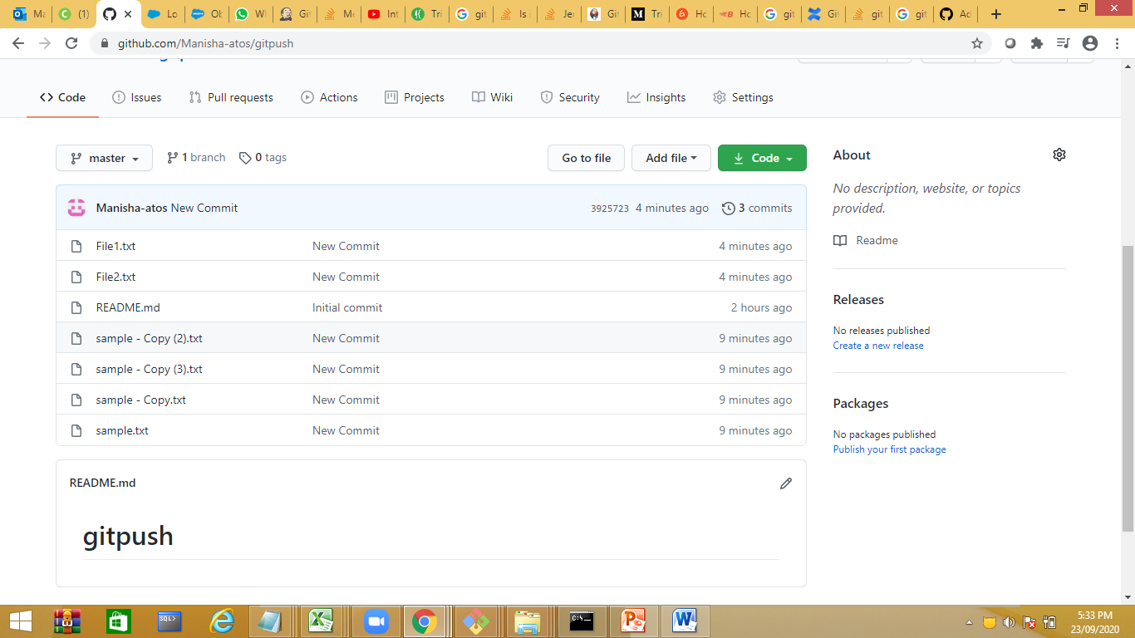

Maven Job:

Build Monitor view

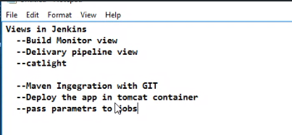

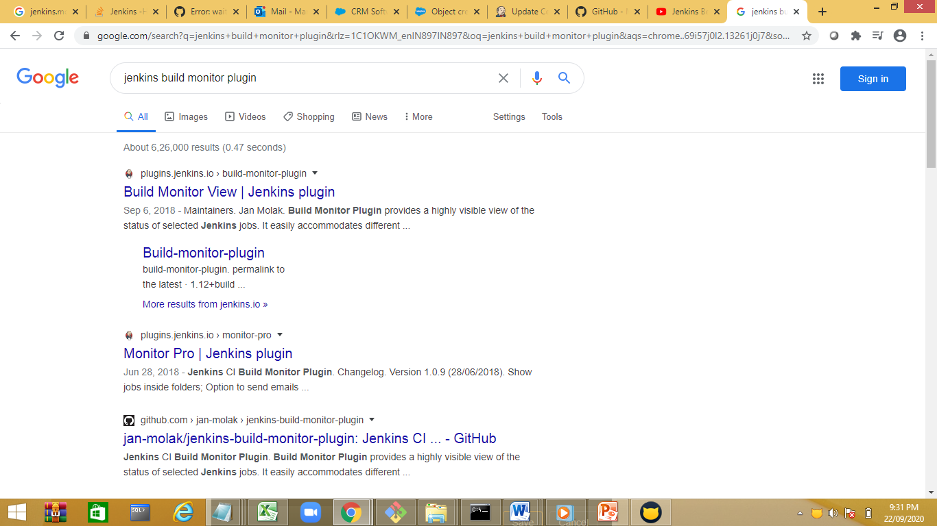

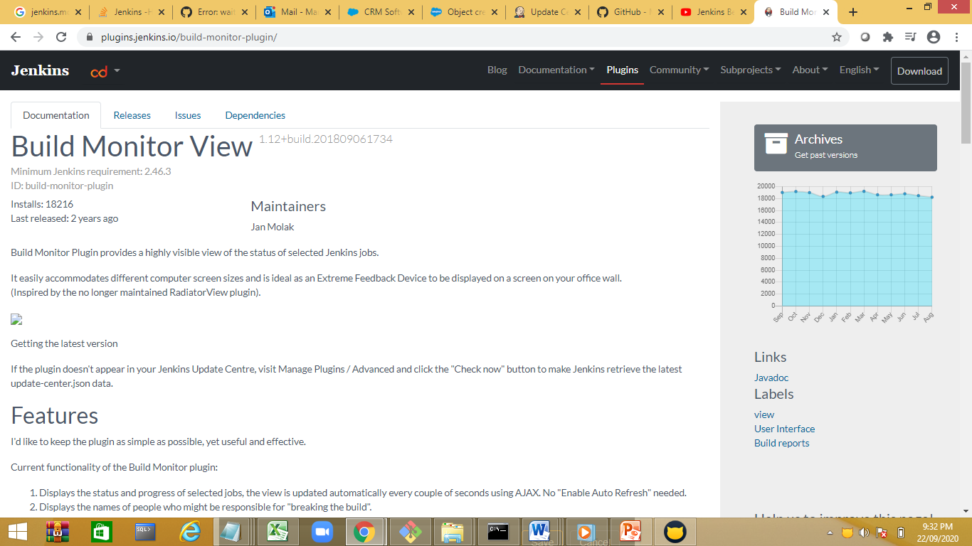

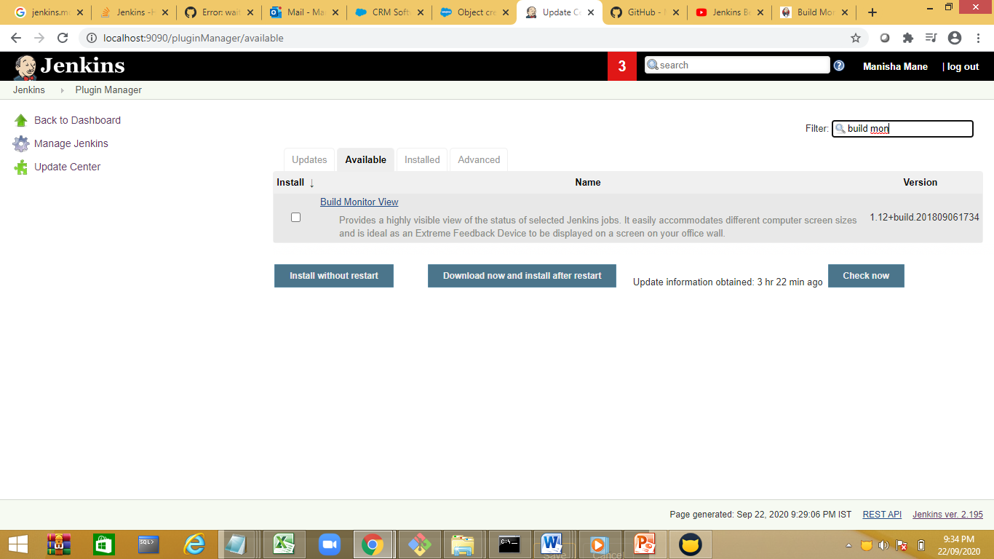

Goto Jenkins and click on + symbol

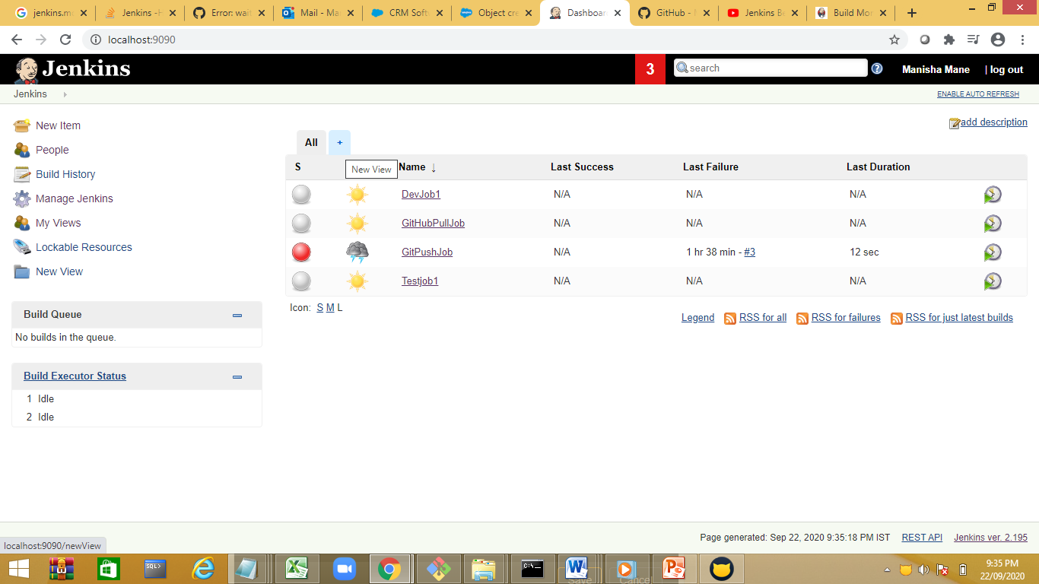

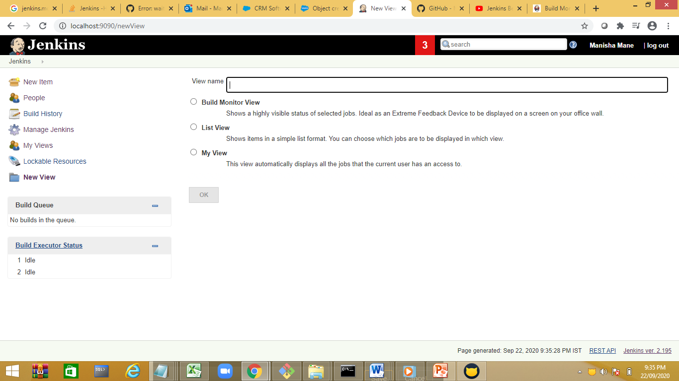

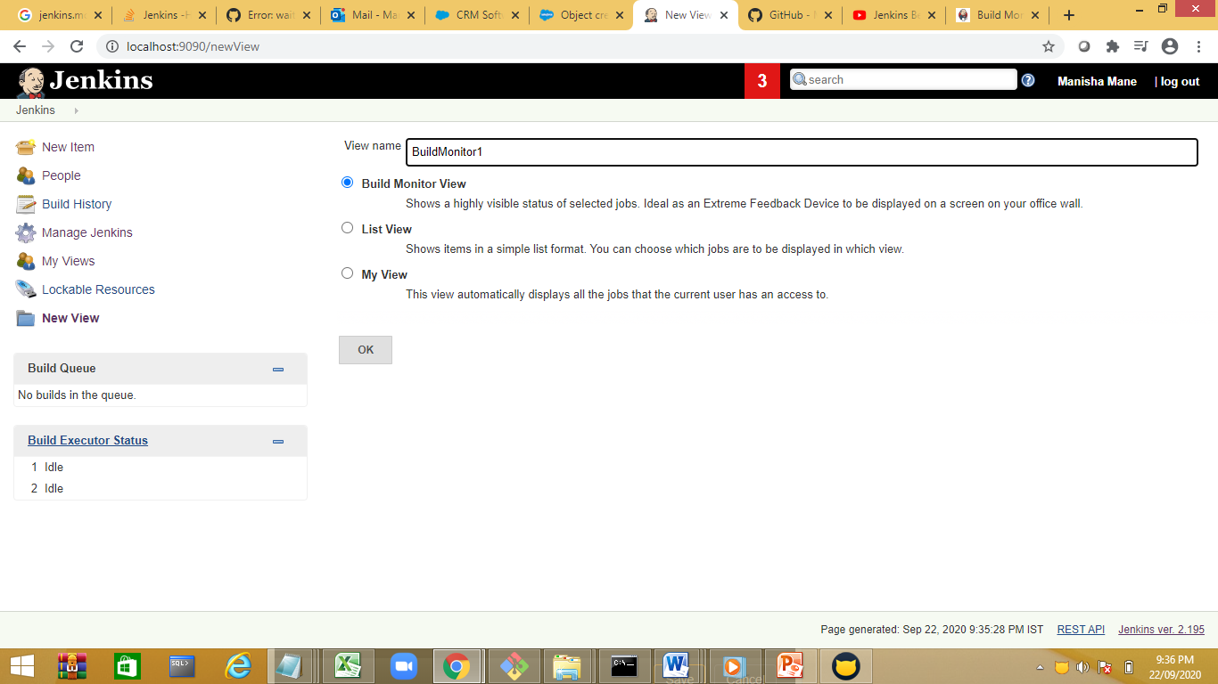

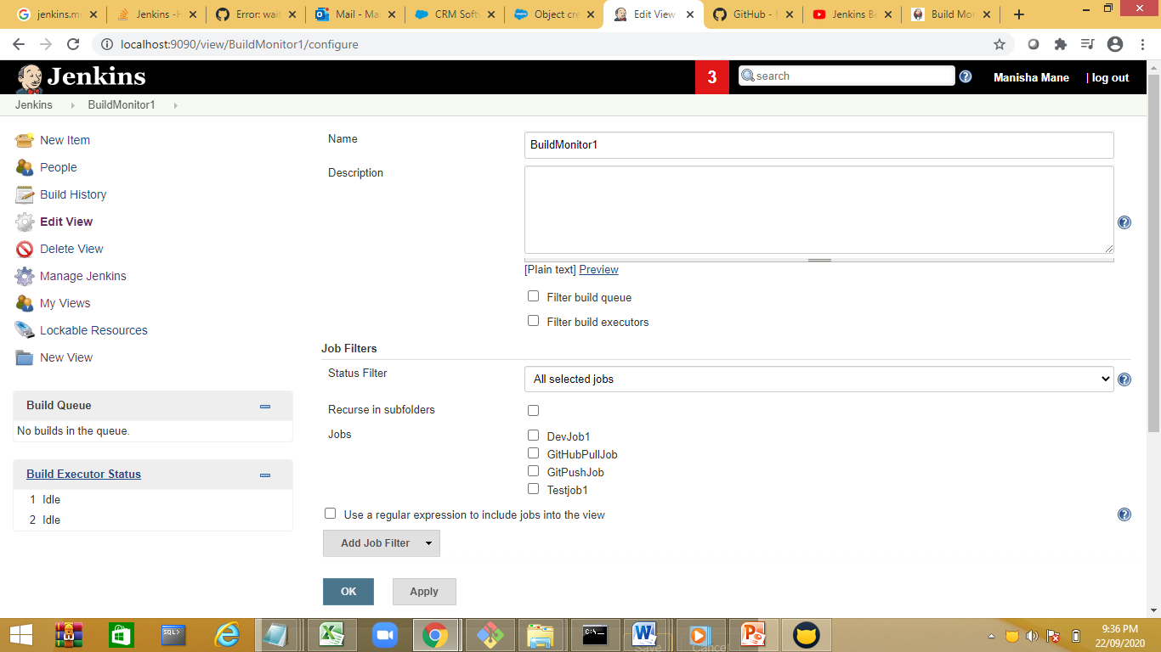

Here we can select filter, order by option

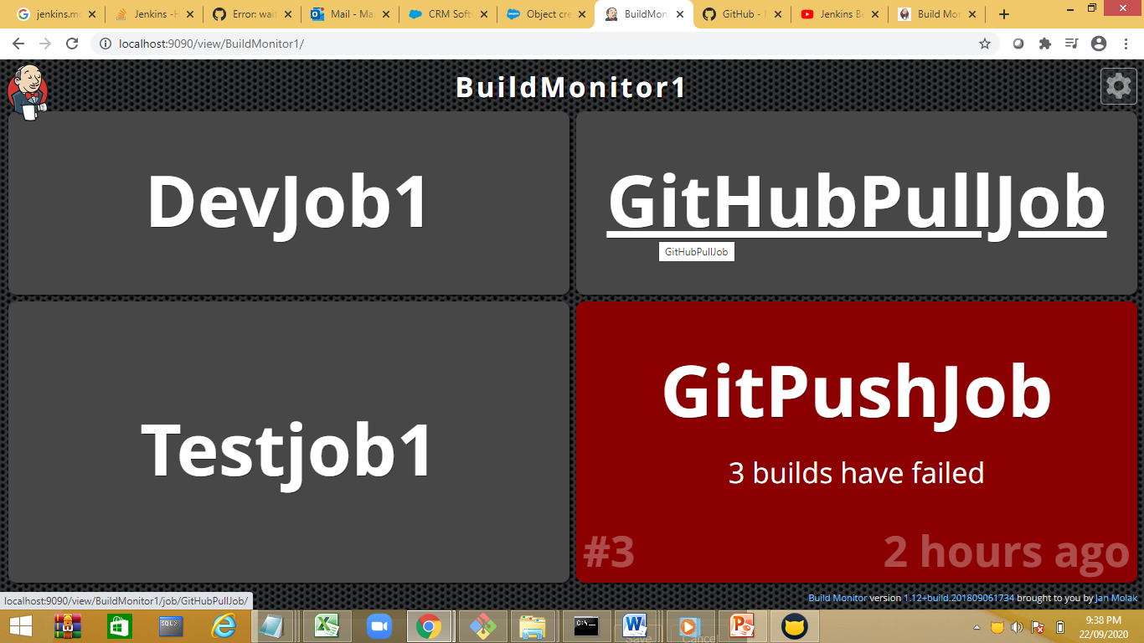

Delivery pipeline view :

Chain jobs in sequence in upward /downward

Demo

Create a job

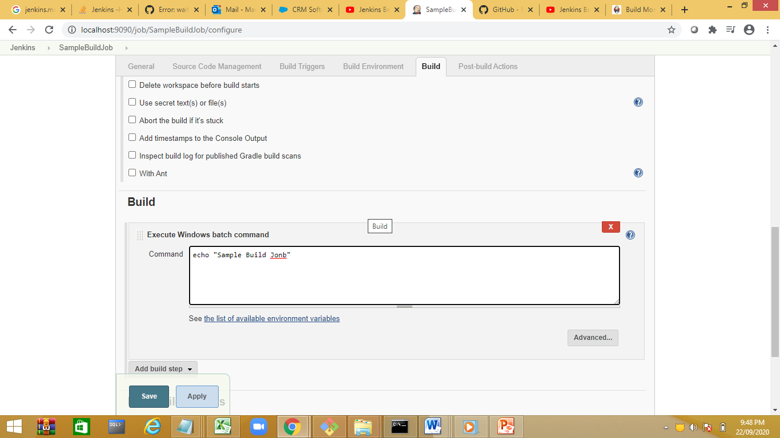

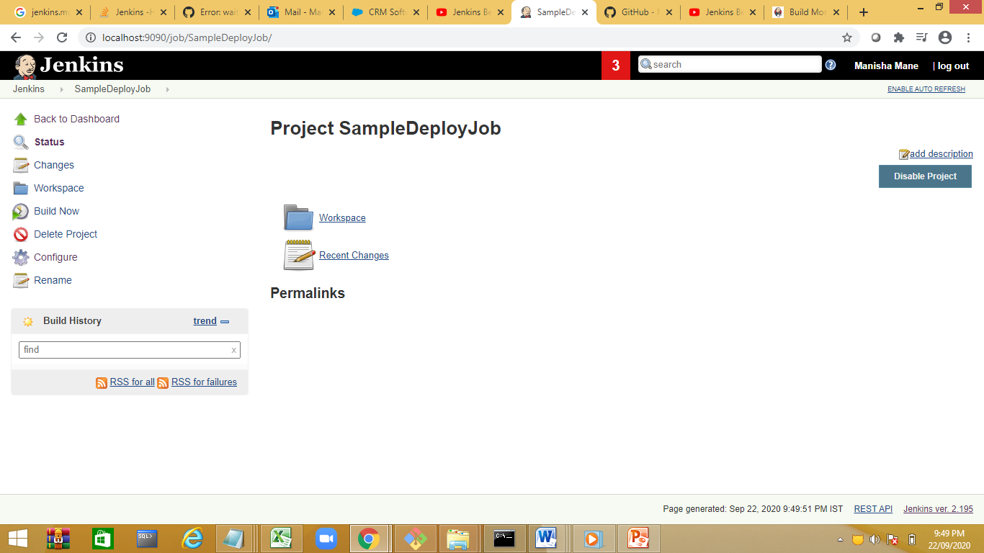

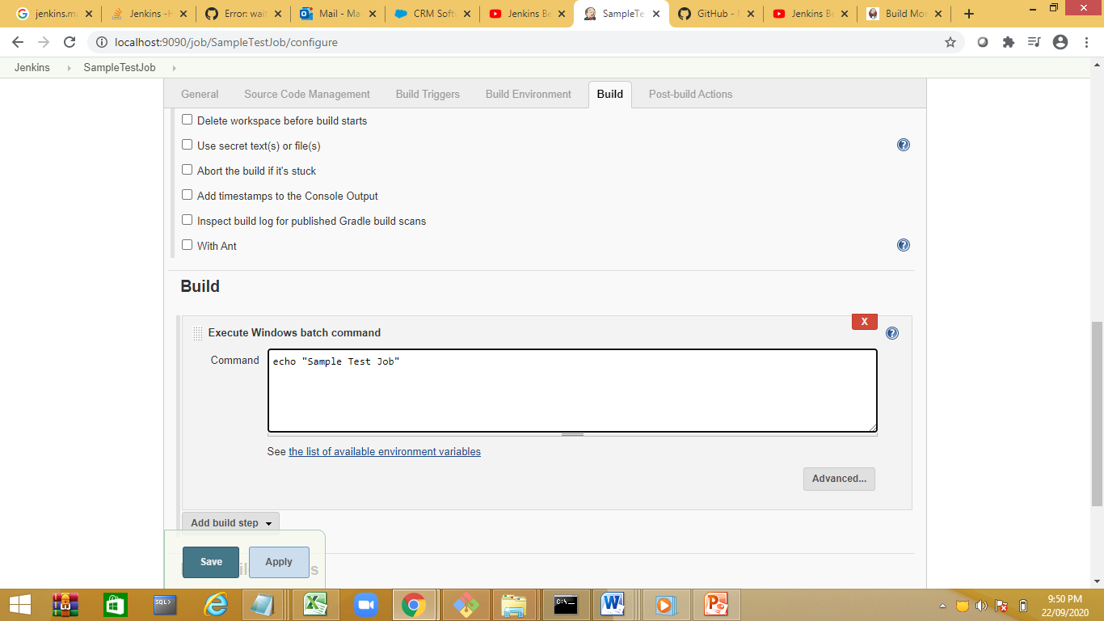

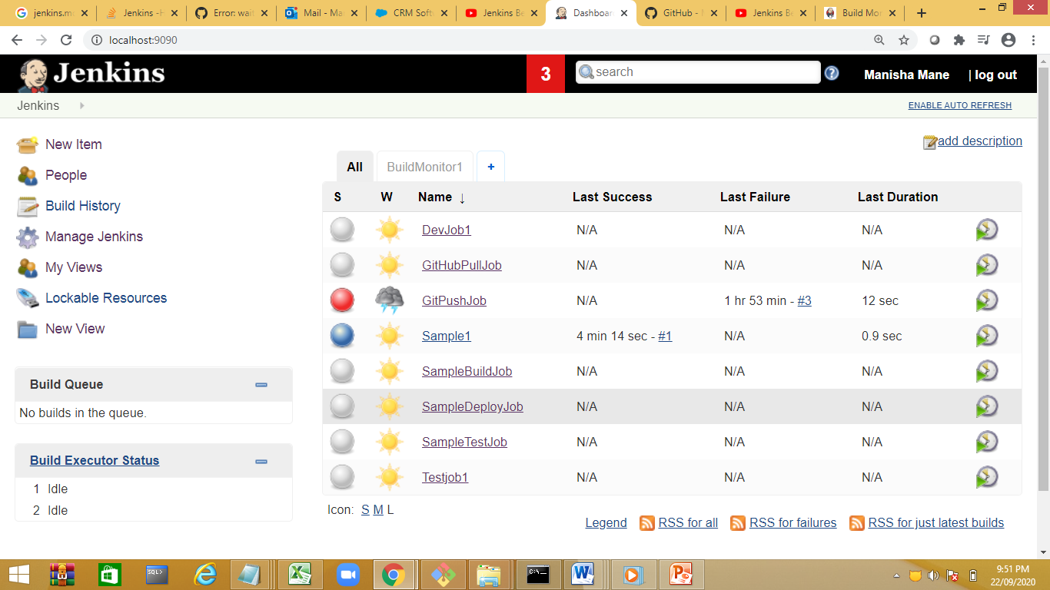

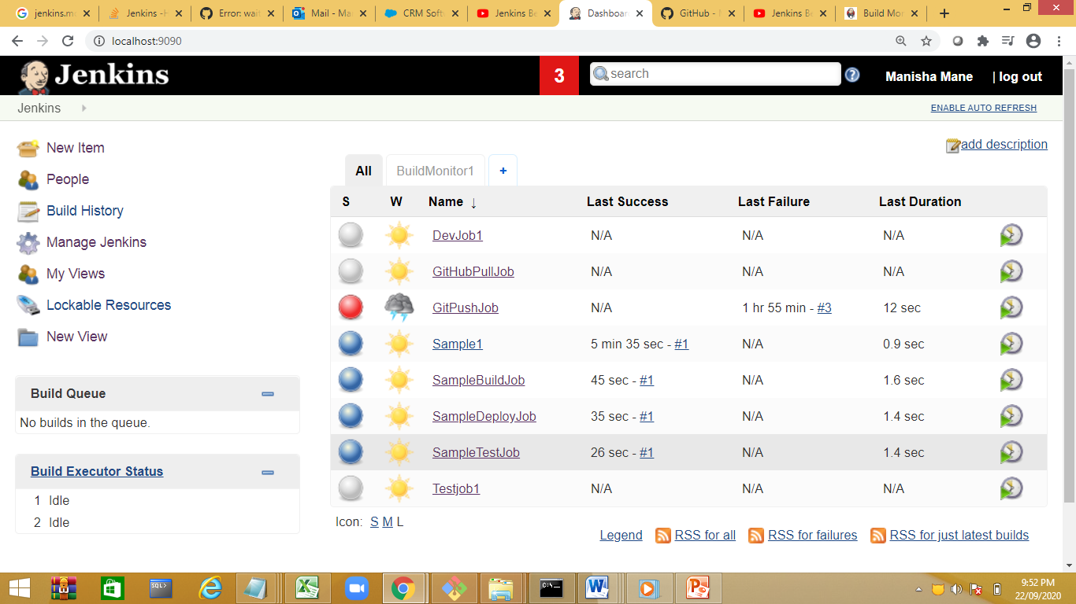

Configure a pipeline

We can configure an upstream or downstream.

SampleBuildJob🡪SampleDeployJob🡪SampleTestJob

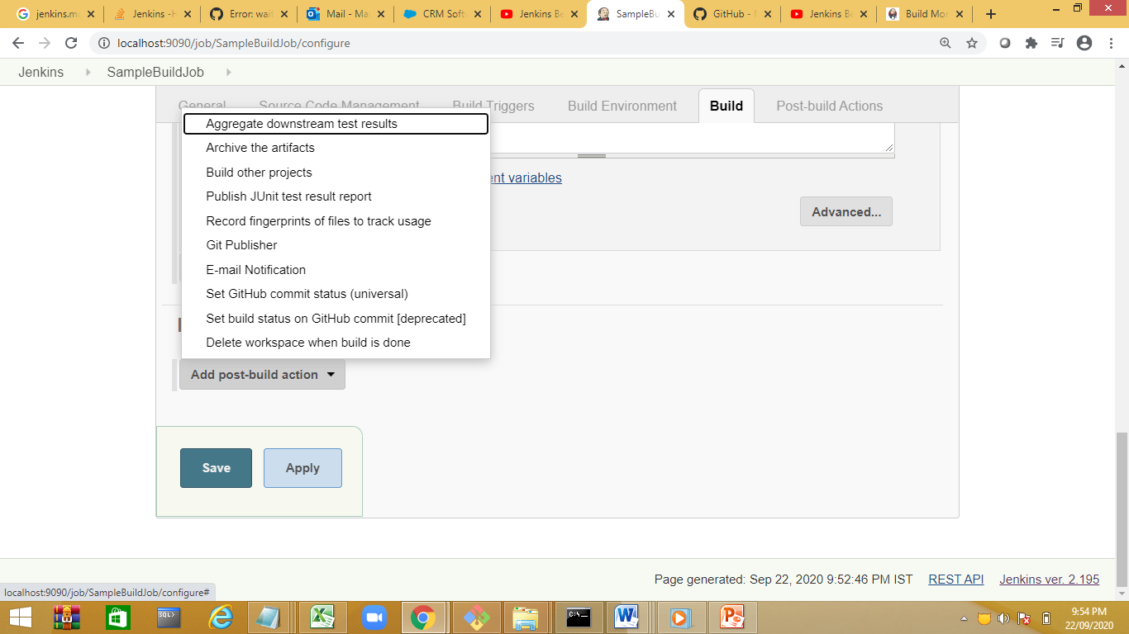

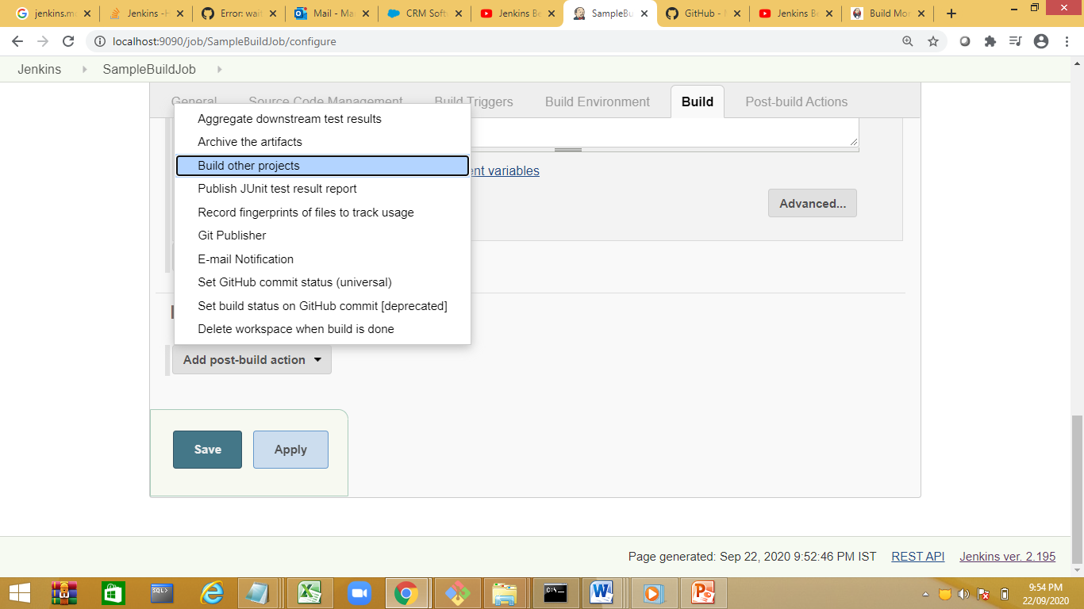

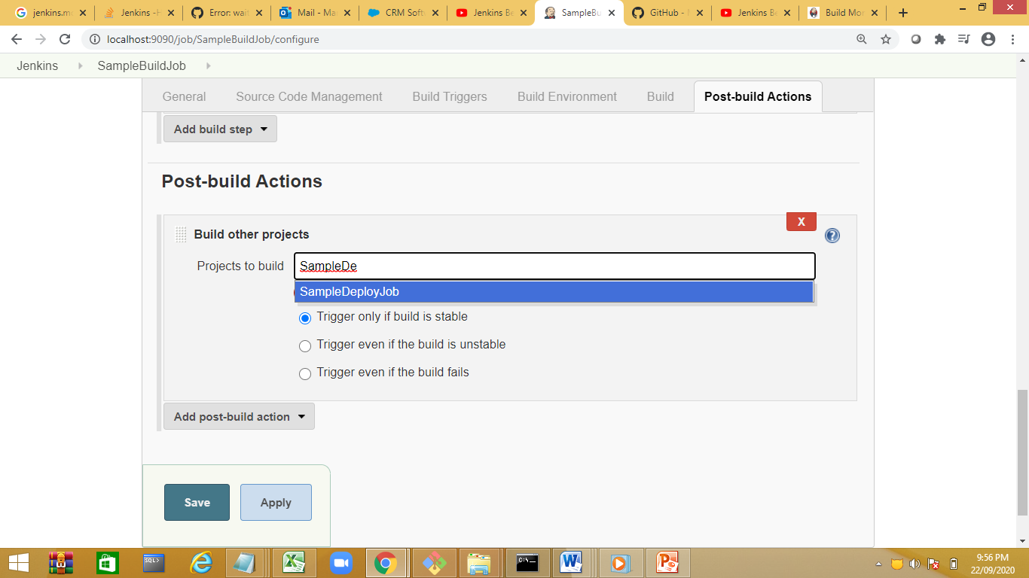

Goto 2nd Job SampleDeployJob

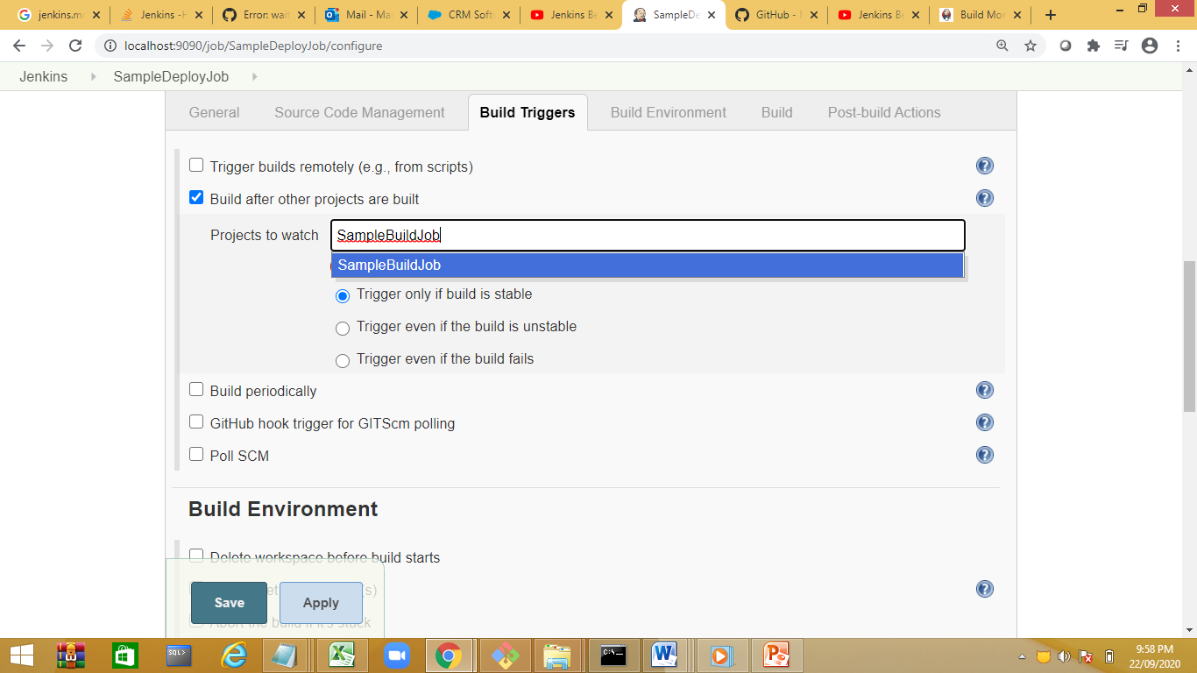

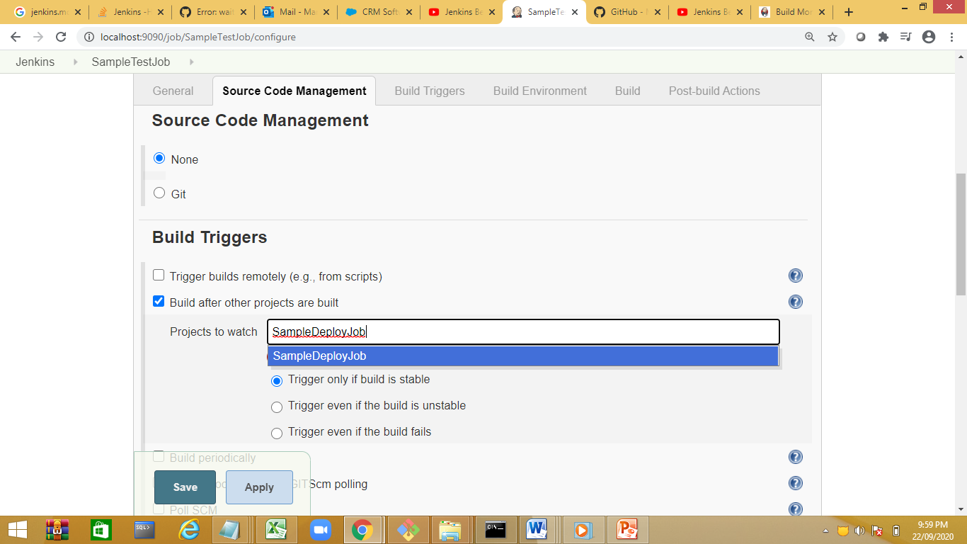

Run the first job first job has 2 runs.

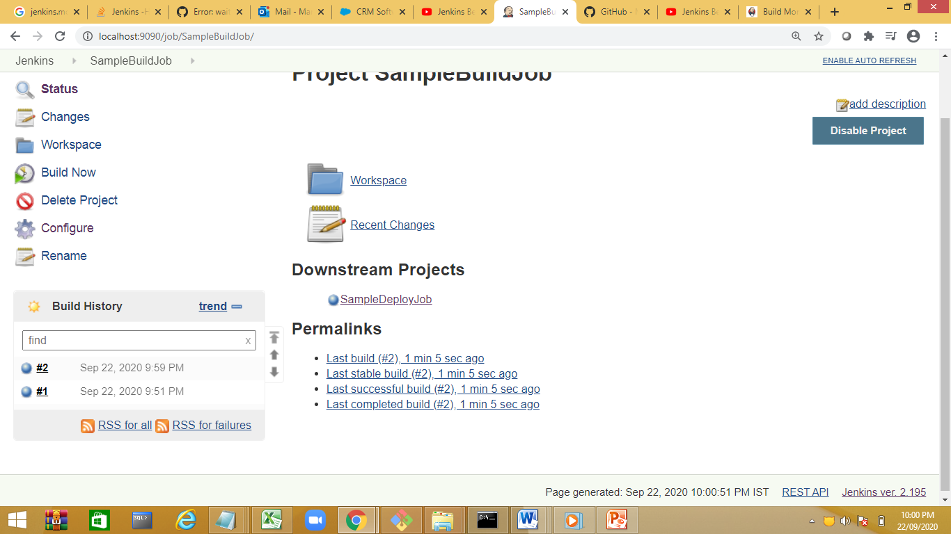

Install Dellivery Pipeline plugin

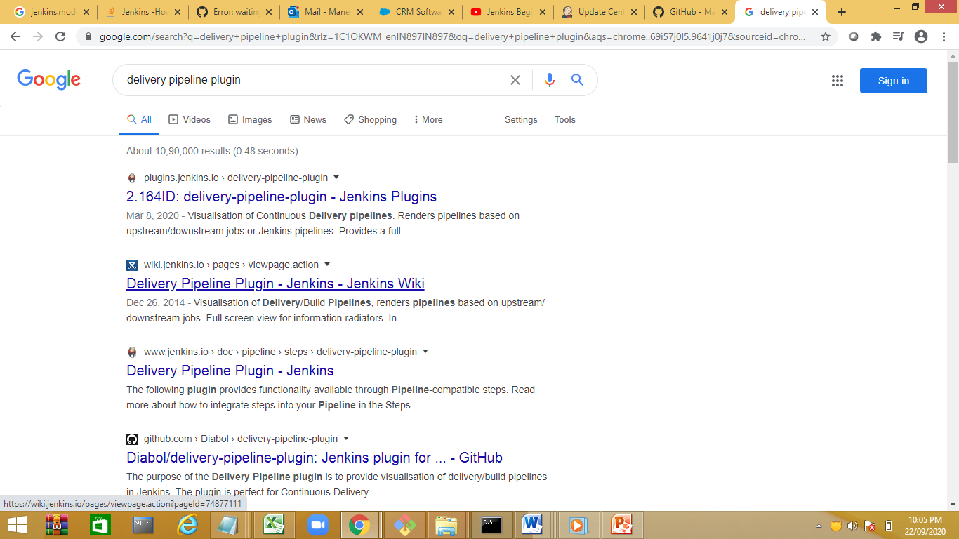

Install delivery pipeline plugin

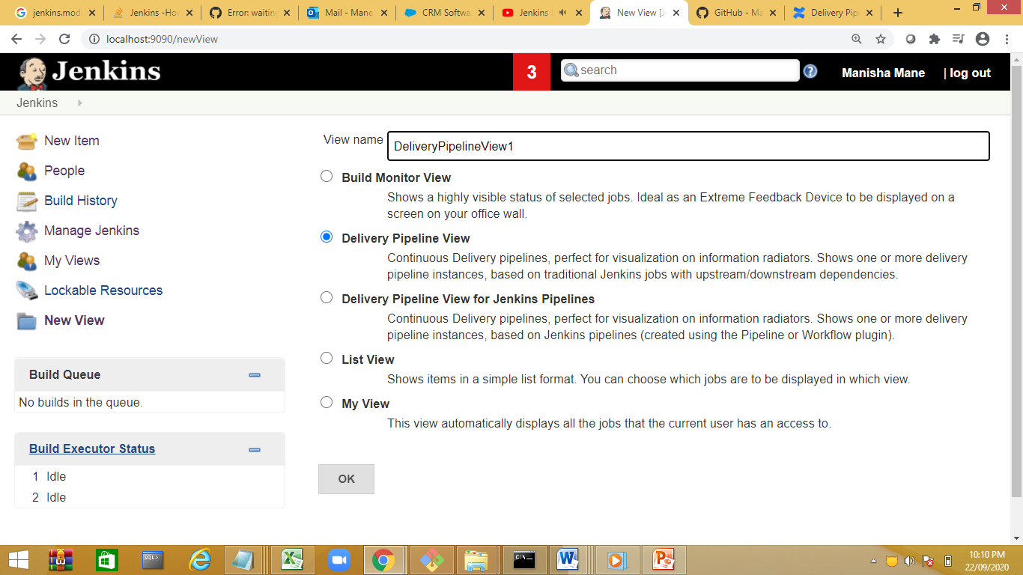

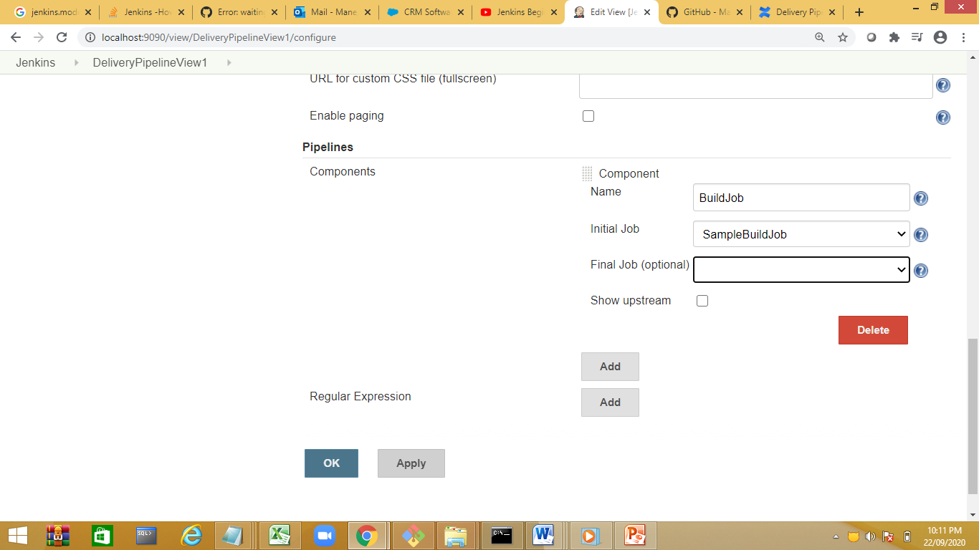

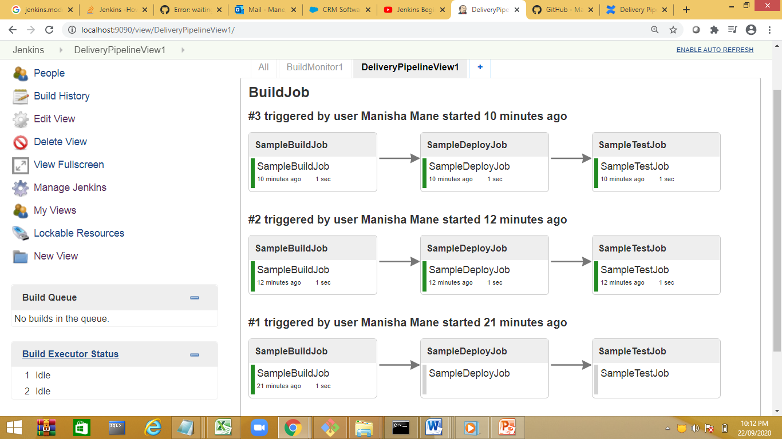

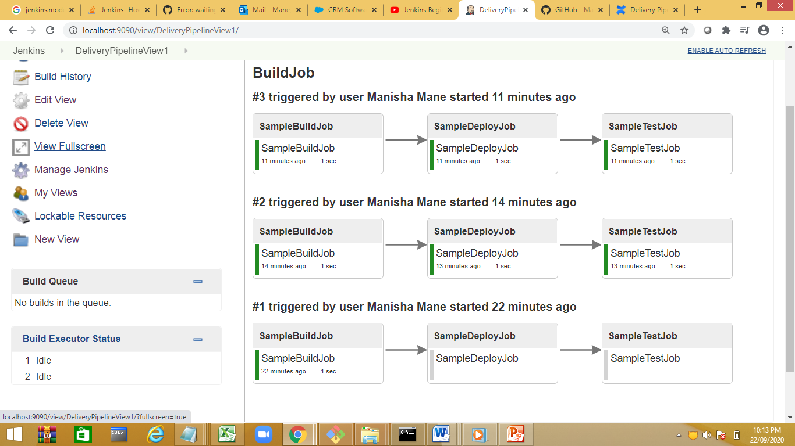

View fullscreen

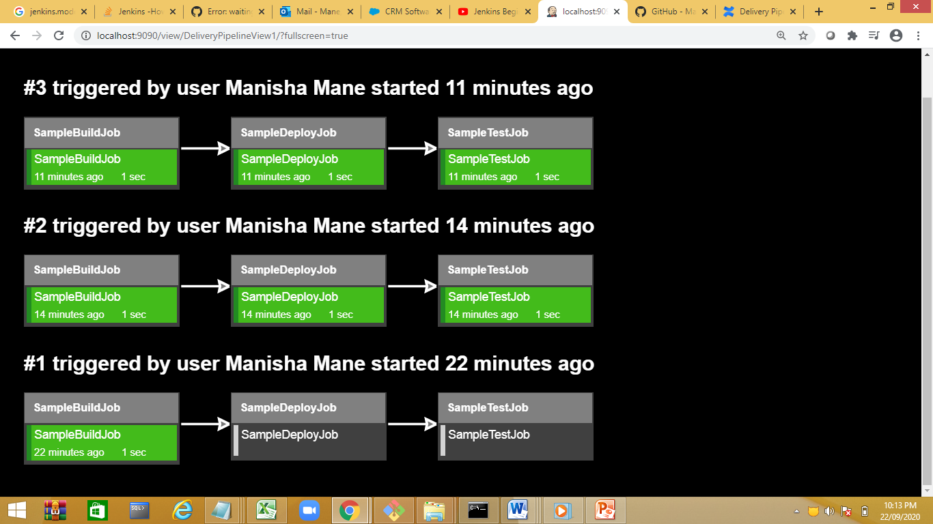

Goto edit view

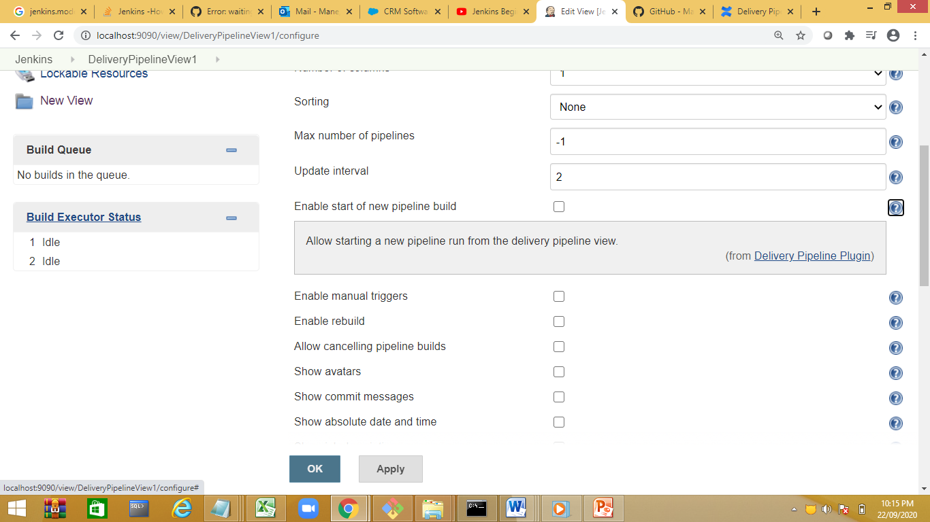

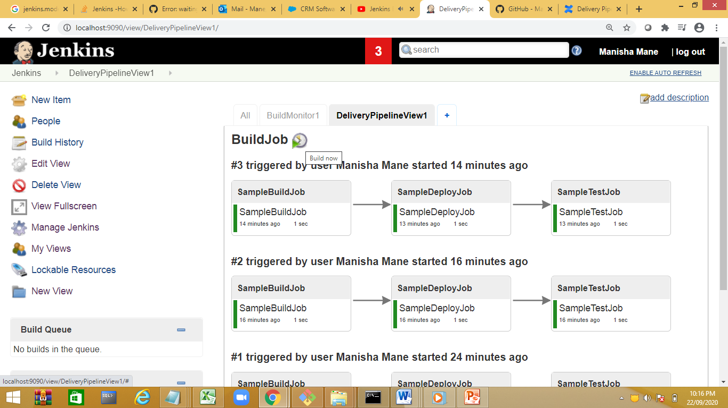

Manual trigger

Enable rebuild

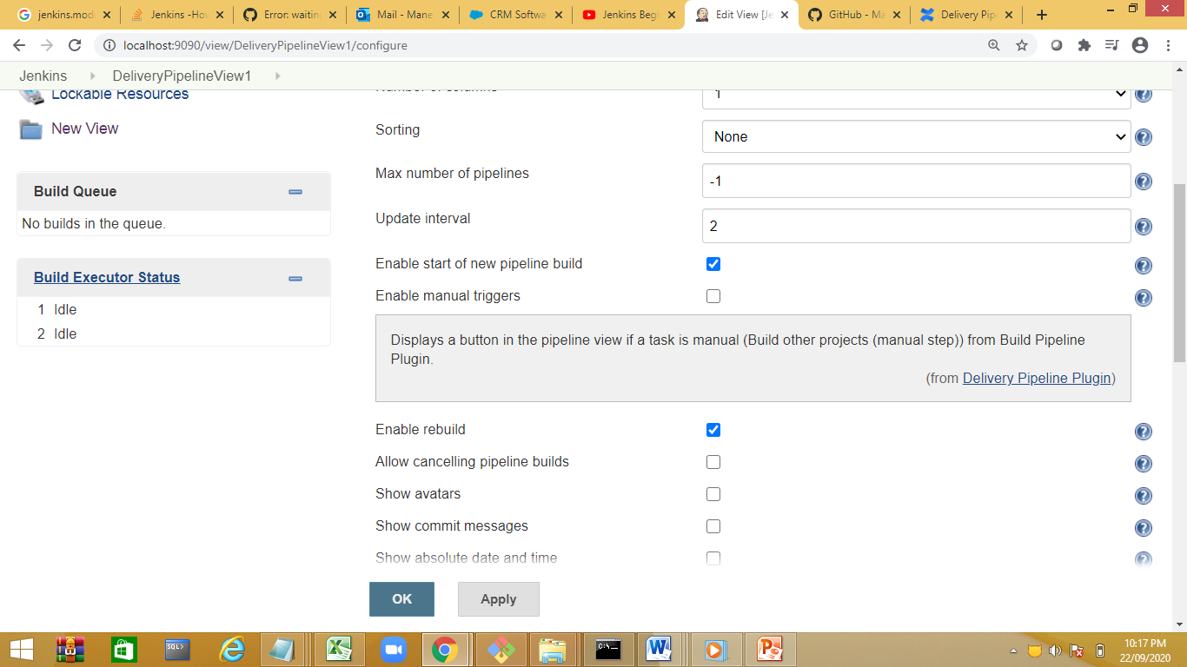

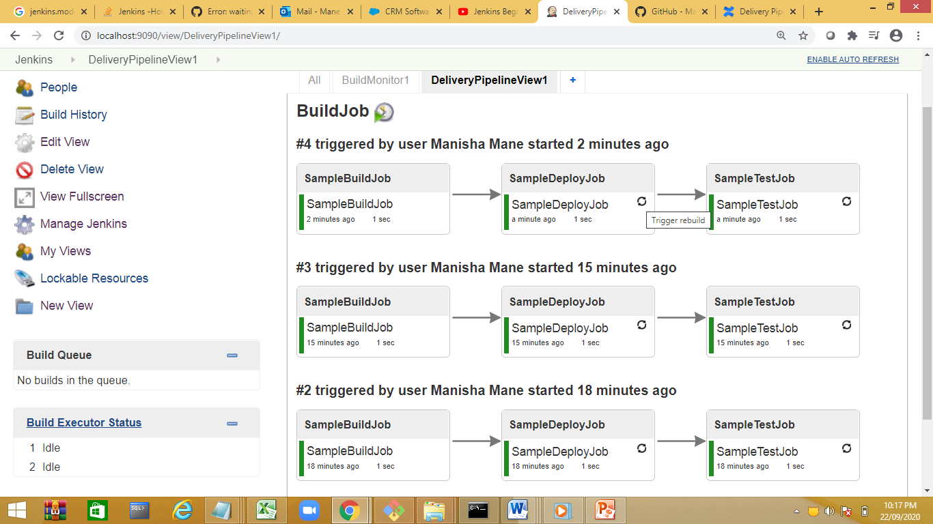

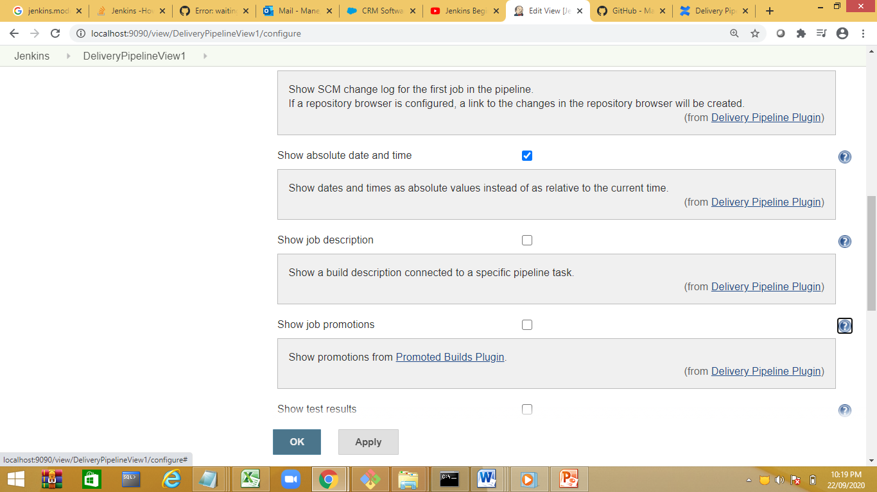

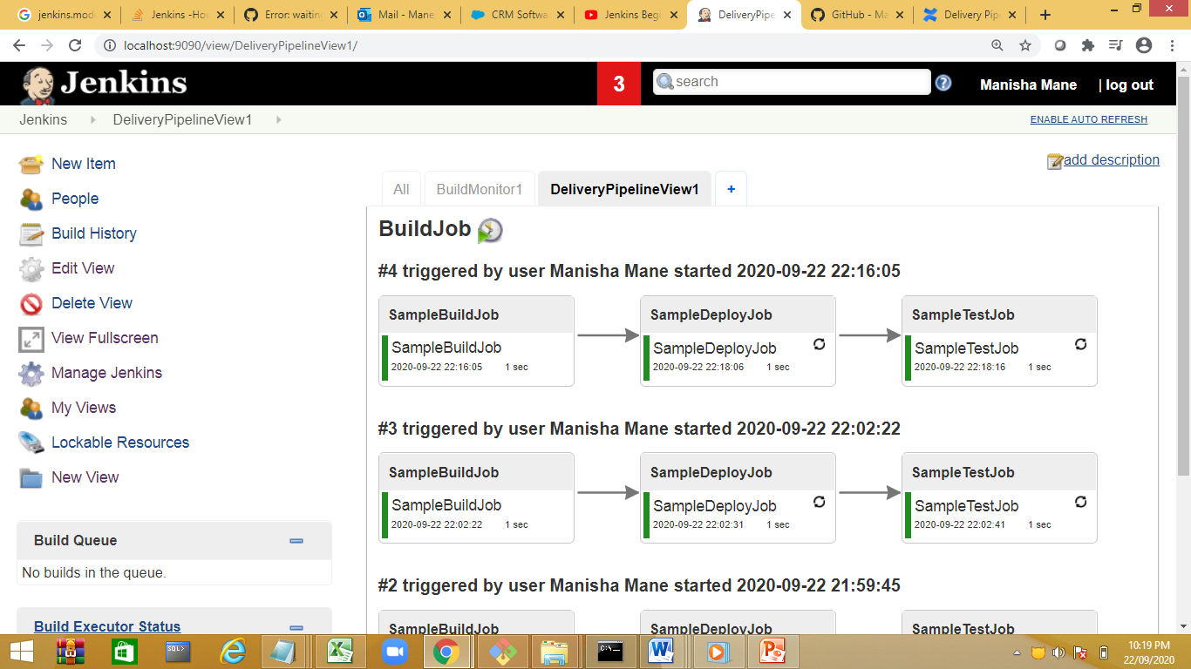

<https://www.youtube.com/watch?v=ndLbn24OwQg>

check for catalight view:

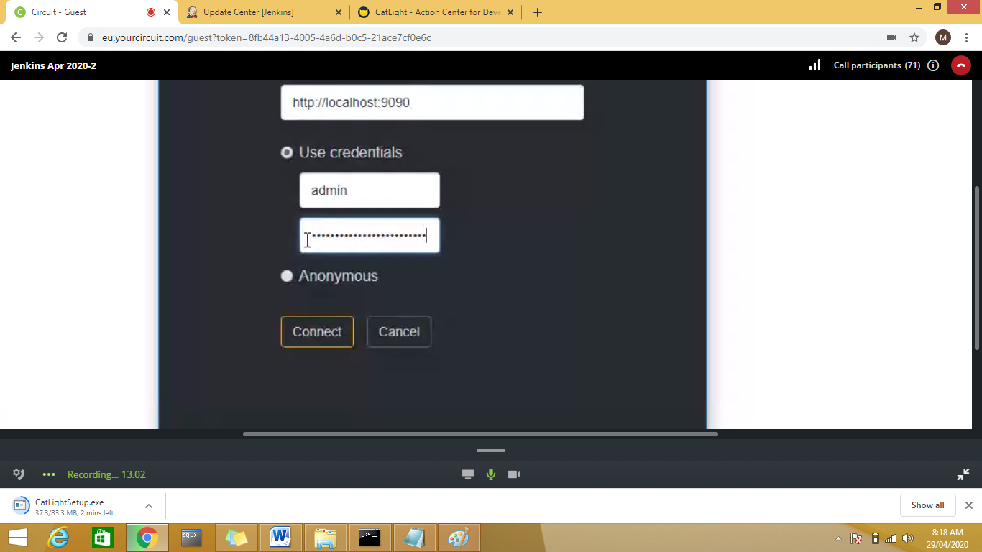

Periodic job running: pattern is used

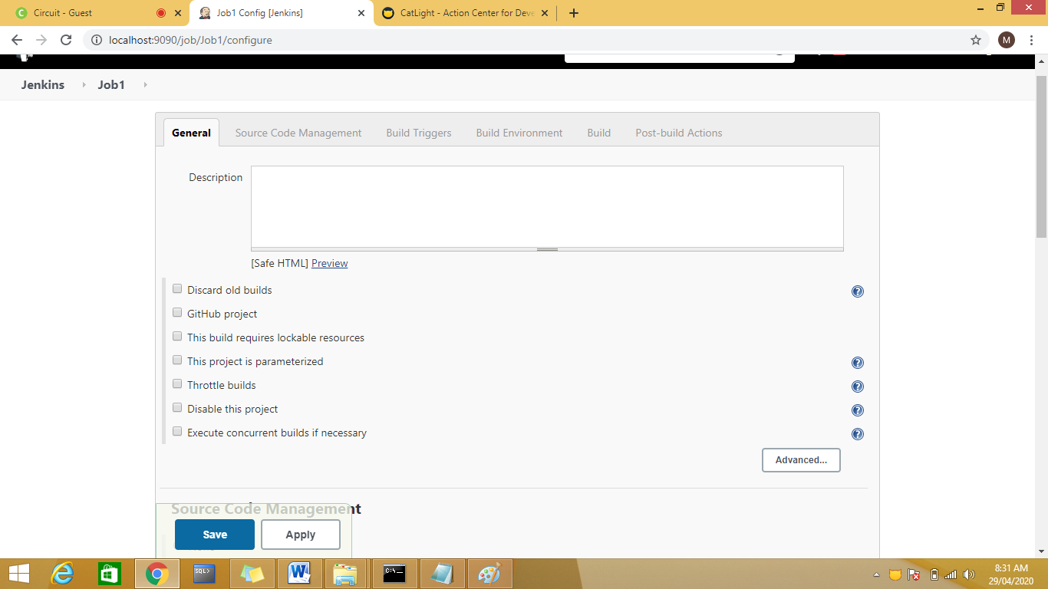

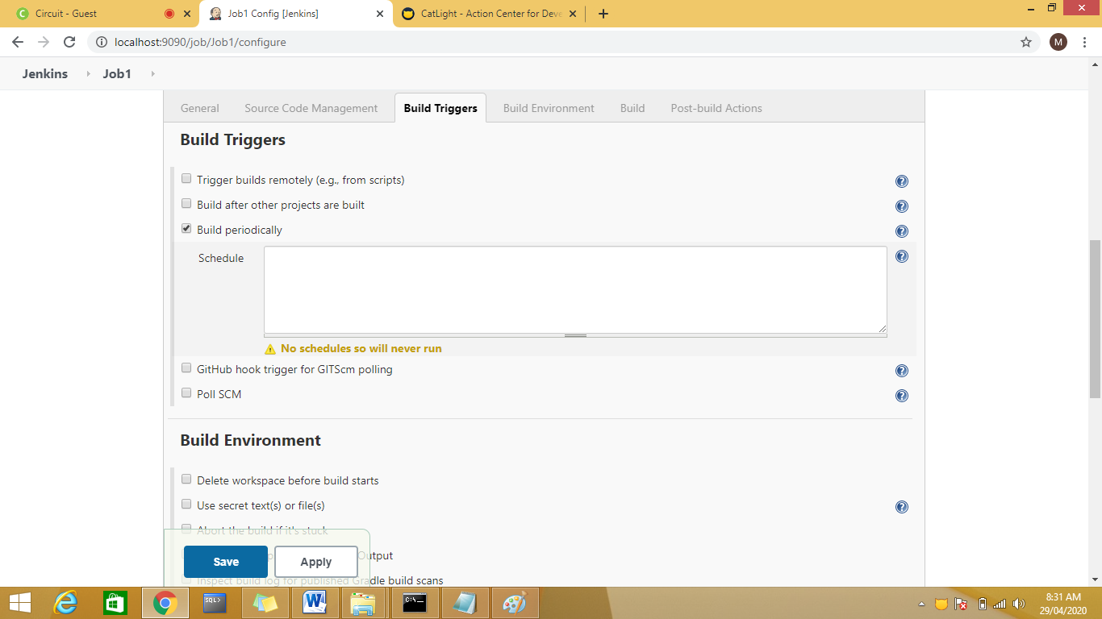

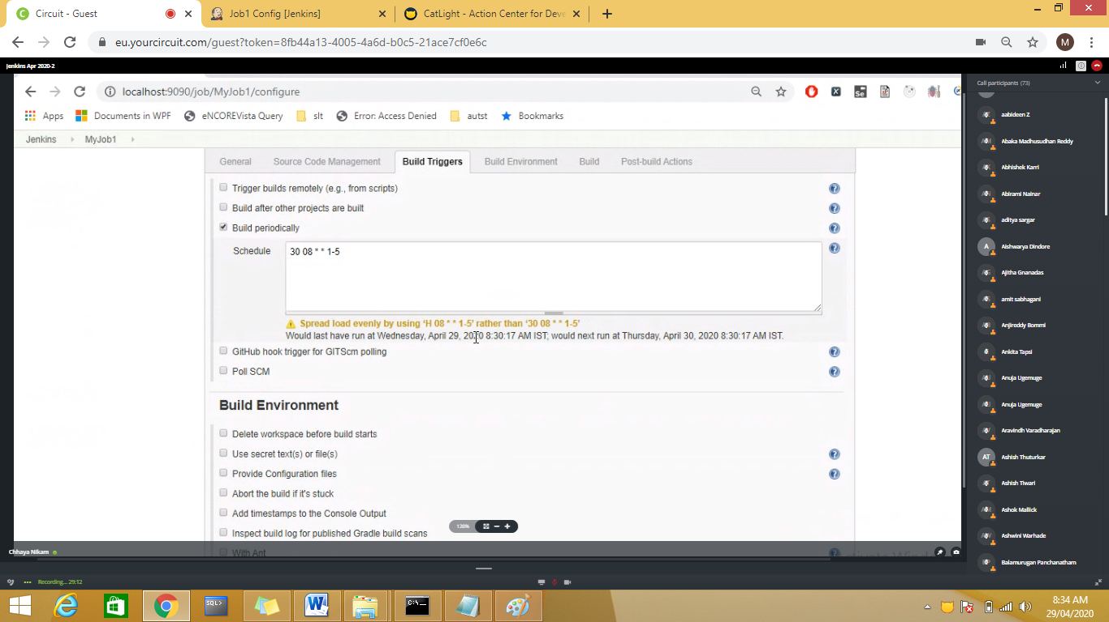

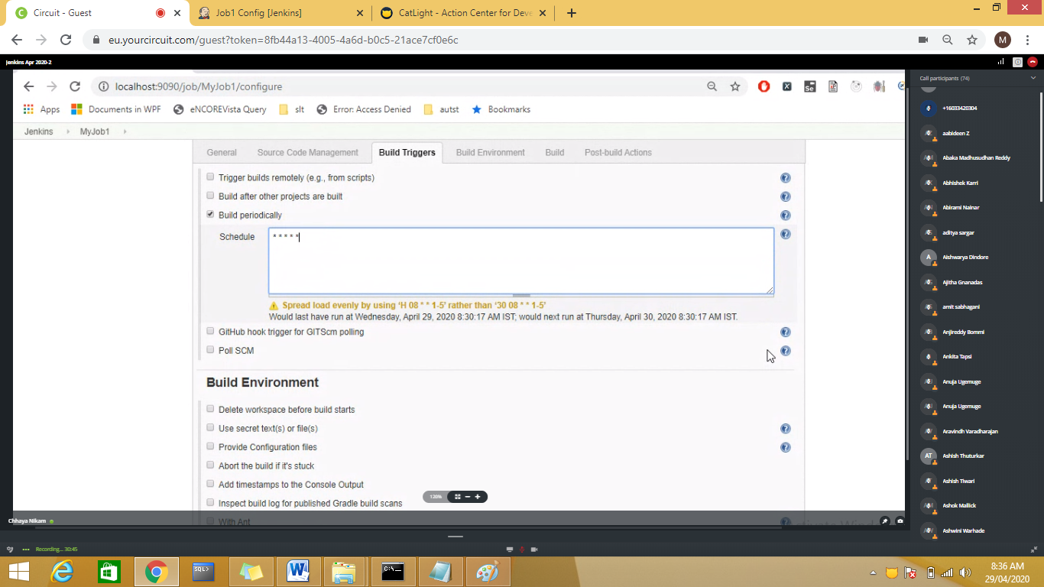

*****--per minute

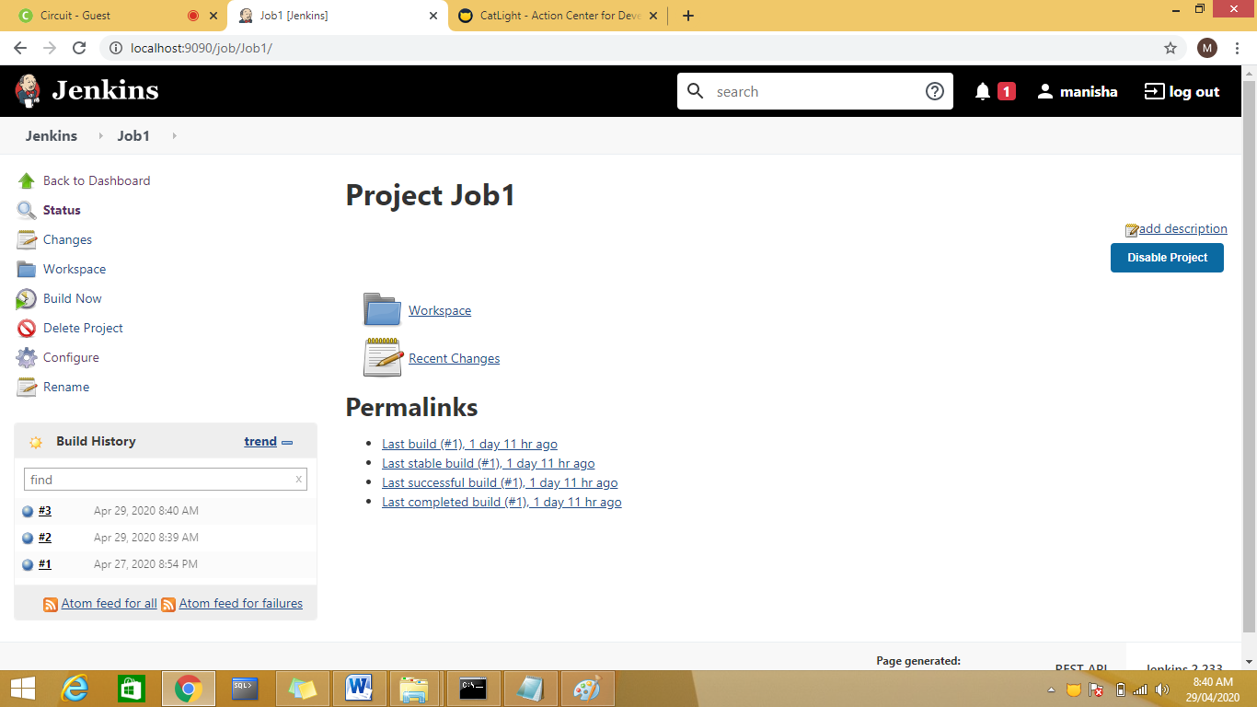

Integarting Maven with Jenkins

1.Check for maven integration plugins

2,.create a maven job ex MavenDemo1.

3.Jenkins🡪Global Tool confi

Set JDK and maven

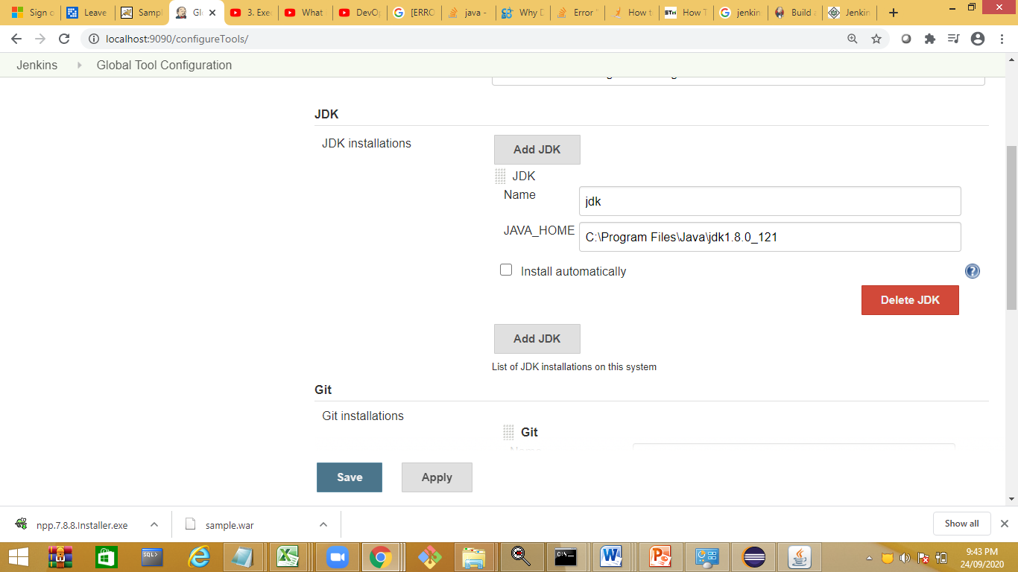

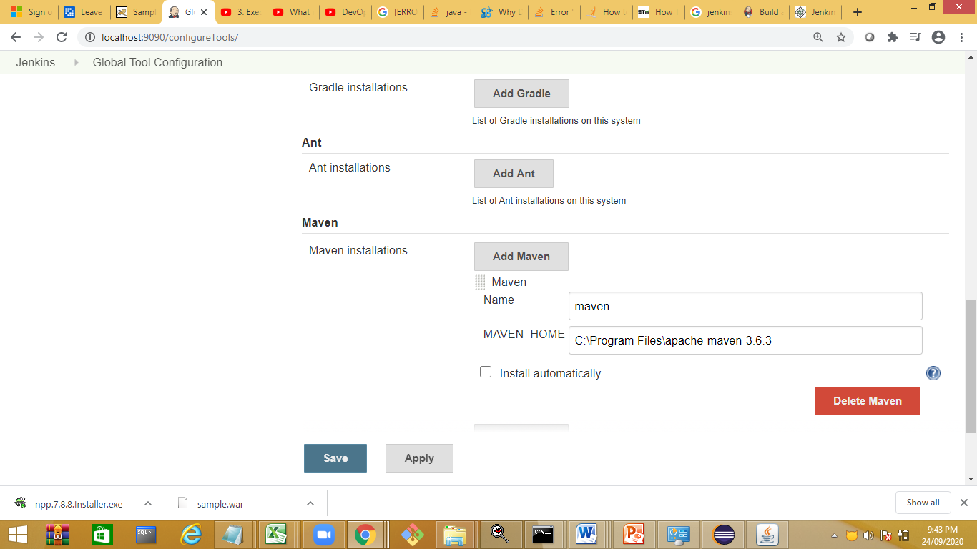

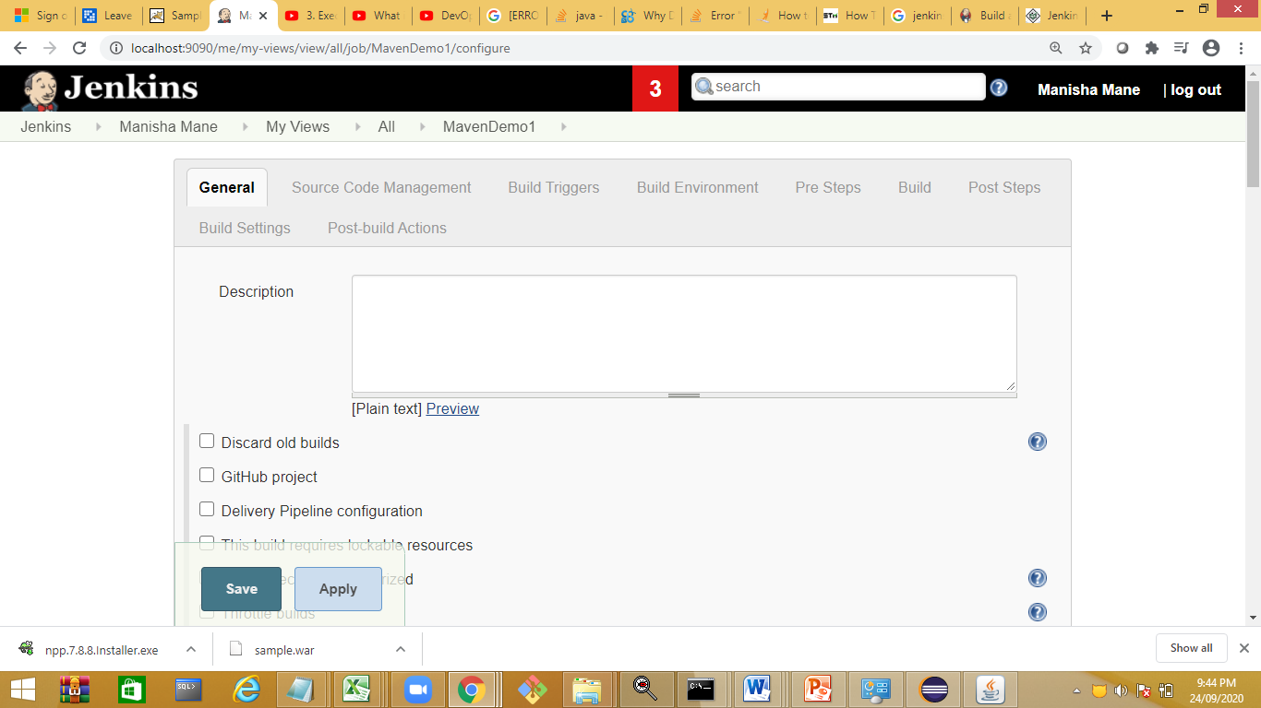

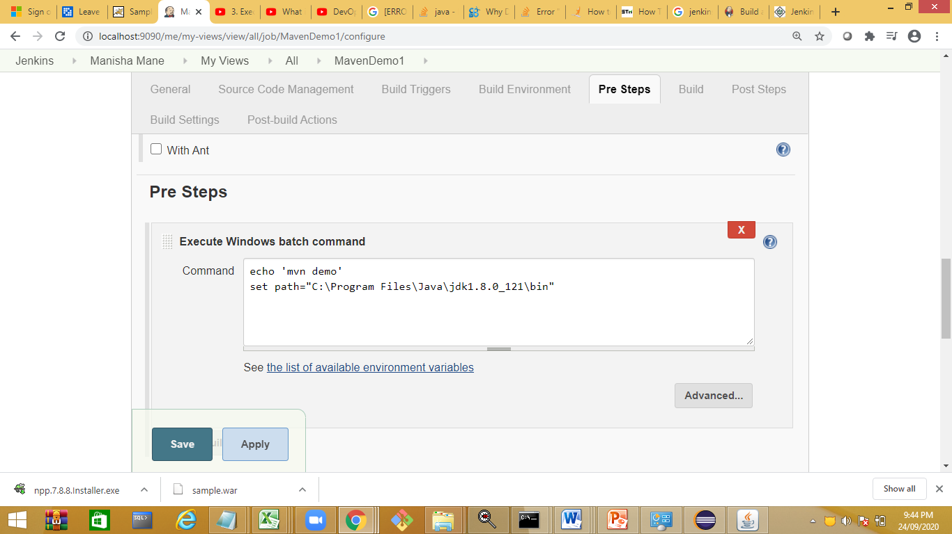

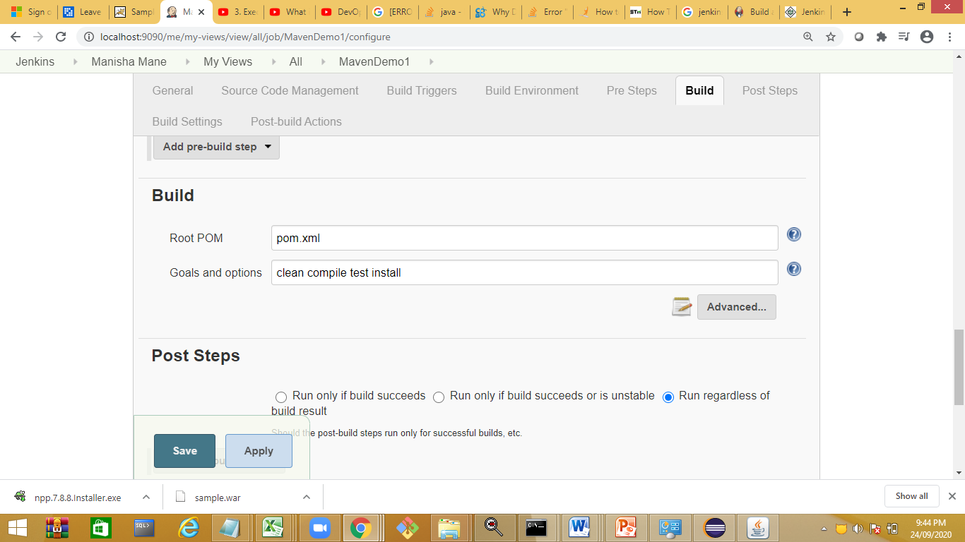

Build the app

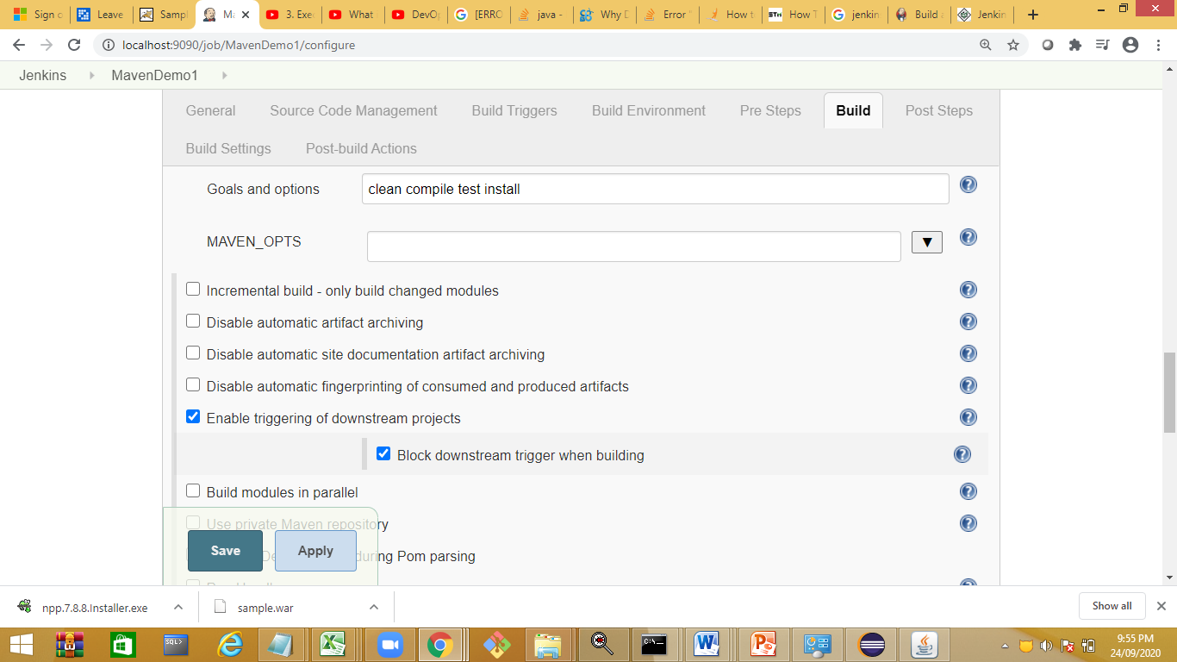

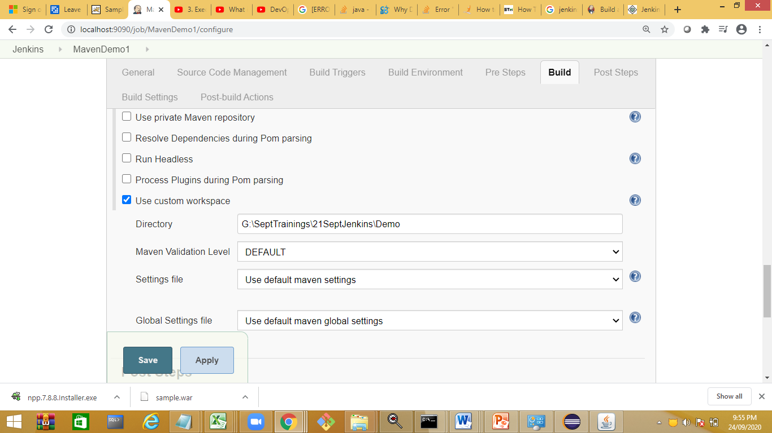

Jenkins job import and export

**https://learn-automation.com/import-and-export-jobs-in-jenkins/**

Automate Deployment of war in Tomcat:

Downloas sample war file

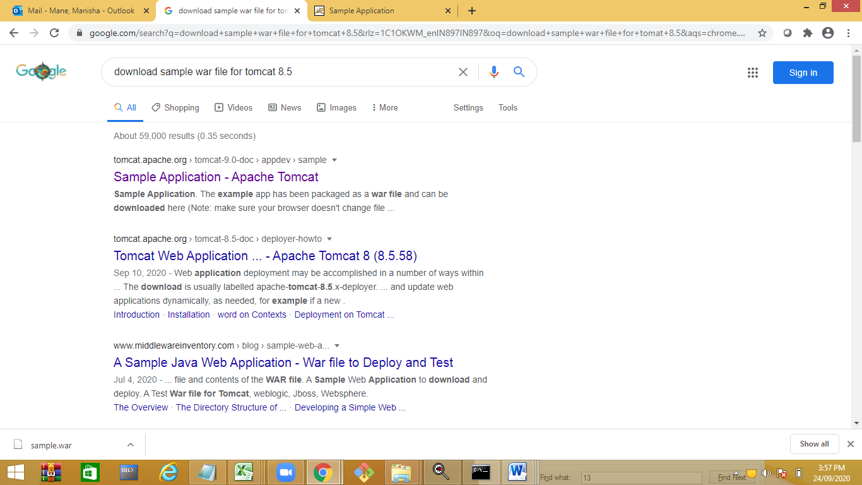

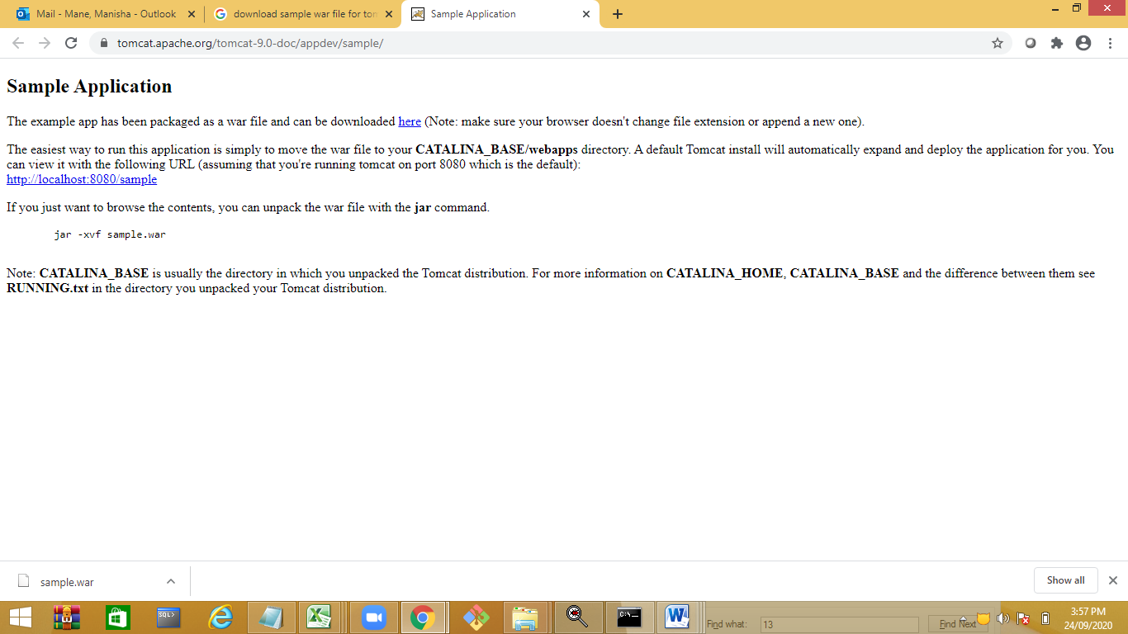

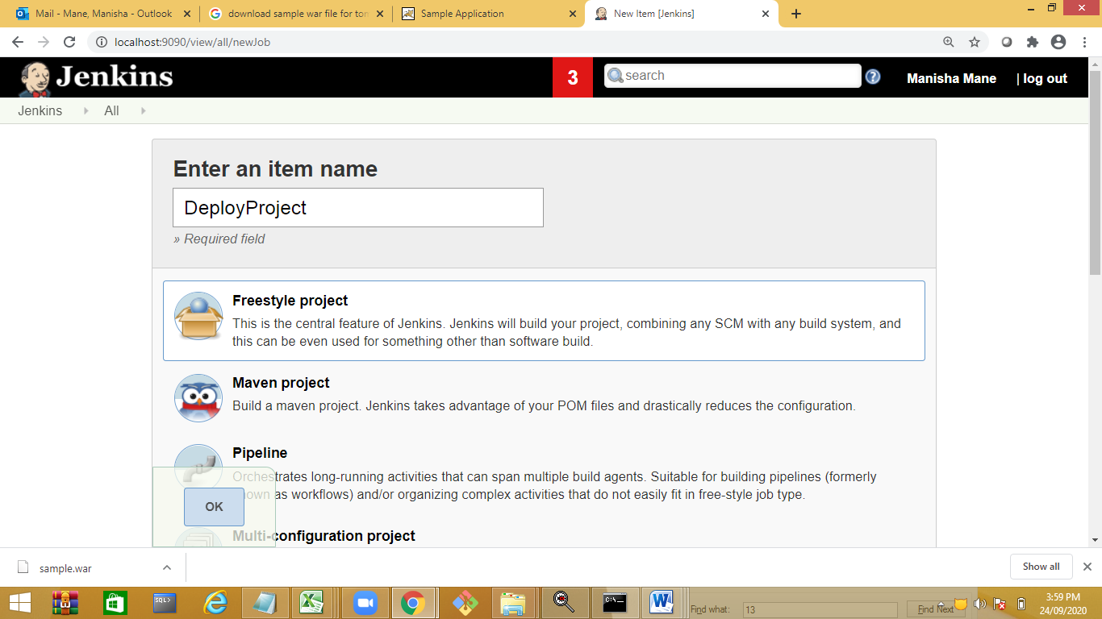

Copy the war file in project workspace

Install plugin

